**0. Introduction.** **(1) 企业组织形式:** *Sole proprietorship 独资企业/个体户:* A business owned by a single person (No formal charter required, very few government regulations; Unlimited liability for business debt since no distinction between personal and business assets; Profit taxed as individual income (single taxation); Equity is limited to the proprietor’s personal wealth; Duration is limited to the life of the sole proprietor); *Partnership 普通/有限合伙人:* A business with two or more owners. (General partnership: All partners provide work and cash; All partners share the profit and losses; Each partner is liable for all the business debt. Limited partnership: At least one general partner, others are limited partners; Limited partners are liable for business debt up to the contributed equity; General partner(s) manage the business and have unlimited liabilities for business debt; Limited partners do not participate in daily management. Features: Partnerships are inexpensive to form, subject to very few regulations; General partners have unlimited liabilities for all debts; Limited partners enjoy limited liabilities; Difficulty in raising large amount of equity, limited to partners’ capacity and desire to contribute; Duration of business is limited to life of partners; Difficult to transfer ownership). *Corporation 公司:* A corporation is a distinct legal entity, separated from its owners; Ownership in a corporation is represented by shares of stock; Ownership is readily transferrable, no impact on existence of business; Unlimited life, not subject to owners’ life or exit/change; Limited liabilities: Owners are liable up to the equity contribution; Double taxation: corporate + individual income tax. **(2) 企业决策者:** *Shareholder => Board of directors(directors can be non-shareholders) => Management team.* (Board chair: voted by the directors; Inside directors, who work day-to-day at the company; CEO, CFO, manager, or any other person who works for the company daily). *Shareholder votes for.* (The makeup of the board of directors; Issuing new securities; Initiating corporate actions like mergers or acquisitions; Approving dividends; Substantial changes in the corporation's operations or policies). **(3) 企业目标:** *Maximize Shareholders’ Value*. (Why not market share, profit, growth, survival, risk management? “Value” encompasses all above; Why not creditors’, employees’, customers’, community’s?: Chief decision makers (executives) are hired by shareholders!) *True or False.* (The goal of financial management for a public firm is to maximize the current value per share of the existing stocks: True; The goal of financial management is to maximize the value of existing owners’ equity: True; We evaluate financial managers’ decisions on the basis of whether they add value to the business owners: True; Maximizing shareholders’ value is equivalent with maximizing firm value: False; Maximizing shareholders’ value is equivalent with maximizing the value of all the stakeholders: False). *ESG affect firm value.* (ESG affects long term cash flow: Government intervention and Emission allowances and carbon allowances auctions; Customer preferences; Brand value; Employee disruption of business (such as OpenAI’s mass exodus); ESG affects discount rate: Non-ESG imposes risk factors (climate change and resource scarcity); Investor preferences: green equity (firm based), green bond (project-based)); **(4) 决策内容:** *Capital Budgeting.* (What long-term investments and projects should be taken? M&A); *Capital Structure.* (How should we raise finance for our investments? Should we use debt or equity? What percent?) Working *Capital/Liquidity Management.* (How do we manage the day-to-day finances of the company?) *Related People.* (Corporate managers: Capital budgeting (long-term asset investment decisions); Financing decisions (debt vs. equity); Acquisition, Going Public, Going Private, etc. The basic rules of making good decisions. Investors/ fund managers/ investment bankers: Offer cash in exchange for future cash flows; As investor at buy side, how to judge a good deal; As underwriter at sell side, how to sell a deal.)

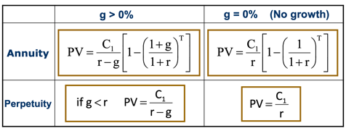**1. NPV and Basic Concepts of Corporate Finance.** **(1) The definition of value.** An asset creates value for its owner if it generates a positive value of cash flows. *Cash Flows:* Cash Flows occur in the future; Unless contractually fixed, cash flows need to be forecasted; For non-financial assets (e.g., cash flows from investment projects), cash flows can be conceptually challenging. *Value-related Decision:* Acquire an asset in exchange for future cash flows; Corporate Manager: Invest in real assets which generates future cash flows; Investors: Invest in financial assets which entitle the owner to future payments (Bond/Loan: Principal & Interest Stock: Dividend and Capital Gain); Value of a single unit of asset is its fair market price. *The value of Money:* Opportunity Cost: the forgone benefit that would have been derived from an option other than the one that was chosen. Annuity 定期年金: Cash flows are constant for T periods: C1=C2=…=CT (debt coupon payment); Perpetuity 永续年金: Infinite series of equal payments: C1=C2=..=CT=CT+1=.. (perpetuity debt 永续债, preferred stock 优先股); Growing Annuity 增长年金: Ct+1=(1+g)Ct, Cash flows that are growing at a constant rate (wage, bonds with “Step-Up” Coupon); Growing Perpetuity 永续增长年金: Infinite series of cash flows that are growing at a constant rate (firm valuation, government sustainability analysis). *Risky Cash Flow:* Investment A generates cash flow of $105 with certainty next year (Risk-free). Investment B’s cash flows are risky (50%=>110, 50%=100). How much are you willing to pay for Investment A? Suppose the risk-free rate is 10%, PVA =105/(1+10%)=95.45, the price will be $95.45. How much are you willing to pay for B? If you are risk averse, **it would be less**. If you are willing to pay $90, what is your discount rate? 𝑃𝑉 =90 =105/(1+ 𝑟 ), 𝑟 =16.67%. The risk-premium for Investment B is 16.67% -10% = 6.67%. Investors require a higher return for riskier financial assets. **(2) NPV.** Net present value: the present value of all future cash inflow & outflows, calculated at the appropriate risk adjusted discount rate. $NPV=-C_{0}+\sum_{t=1}^{T}{\frac{C_{t}}{{\left(1+r\right)}^{t}}}$. NPV measures how much an investment adds value to the investors. The NPV rule is simple: *If an investment/project has positive NPV, then it should be accepted, otherwise not.* **(3) Value of a Firm.** PV of the cash flows the firms is expected to generate now and in the future. PV of firm’s cash flows = PV of cash flows to stockholders + PV of cash flows to debtholders. Value of a Firm (V) = Market Value of Equity (E) + Market Value of Debt (D) (E = # of shares * Price per share, D = # of bonds * Bond Price or market value of private debt) **(4) WACC.** Cost of capital of a company is the discount rate for cash flows of a company. One of the main ingredients of any valuation or capital budgeting exercise is to determine the appropriate cost of capital for the firm’s cash flows or that of its projects. For firms with both equity and debt, the cost of capital is the weighted average of *cost of debt* and *cost of equity*. This is called the weighted average cost of capital (WACC). If the company pays corporate tax at rate of 𝜏: $WACC=\frac{E}{V}E\left(R_{E}\right)+\frac{D}{V}E\left(R_{D}\right)\left(1-τ\right)$. **(5) Example.** A company holds $80 cash today, and has access to one project that requires an initial investment of $80 tomorrow and yields either $100 or $110 with 50%-50% probability in one year. Another financial asset that pays either $100 or $110 with 50%-50% probability is traded in the market at $90. *Will the project be taken tomorrow?* Discount rate $r=E\left(R_{Fin}\right)=\frac{105-90}{90}=16.67\%$, NPV of project $=\frac{105}{16.67\%}-80=10>0$, YES! *What’s the expected value of the firm one year later?* $105. *What’s the value of the firm by the end of tomorrow? $\frac{105}{16.67\%}=90$* . *What’s the value of the firm today?* (Assuming the market has known that the project will be taken tomorrow) $80+$10 = $90 (Firm value = Value of assets in place + NPV of future projects). *What if the market doesn’t know about the project today, and the manager announces it after it’s taken tomorrow?* The price today is $80. The price will jump up to $90 after tomorrow’s announcement. If you somehow knows about the project before other investors do, you will want to buy the stock today at $80 and sell it at $90 tomorrow. Of course, if your purchase order is big, the other investors may infer that some good news is on the way and charge you higher than $80. **(6) Summary.** An asset creates value for its owner (investors) if it generates a positive value of cash flows; NPV measures how much an investment adds value to the investors; For a risky cash flow, the discount rate is the expected return on a financial asset of comparable risk; In an efficient market, investing in financial assets earns zero NPV; The capital budgeting rule of corporate finance (for real assets) is to take positive NPV projects; Firm value incorporates the NPV of ongoing and potential projects; The cost of capital or discount rate for cash flows of a firm is the a weighted average of the cost of equity and debt.

**2. Capital Budgeting Method. (1) IRR.** IRR is that discount rate for which the NPV of the investment is exactly zero. *Basic:*In particular, **NPV(IRR) = -C0+PV(IRR) = 0**. The PV of the future Cash Flows from the investment, discounted at the IRR rate, exactly equal the initial investment. If the initial investment is invested at a rate equal to the IRR, then it can exactly replicate the future cash flows of that investment. *IRR Project Accept/Reject Rule:* **Accept if IRR > actual discount rate; Reject if IRR < actual discount rate**.*IRR&NPV:*If cash flows are conventional, (i.e. first negative and then always positive), the IRR criterion accepts a project if and only if its NPV is positive. Yet, in some situations, decision making within an organization may be easier if IRR rule is followed. *Why IRR?* Return-based evaluations are easier for investors (Example: evaluating the performances of wealth management assets); The same mindset might be used when negotiating deals, especially when the real discount rate is hard to estimate (Example: VC investments in startup companies). *Two major Drawback:* If cash flows are not conventional, there may be multiple IRRs. If projects are mutually exclusive, IRR may not be sufficiently informative. Suppose cash flows are -60, 155 and -100 (Example: a mining project: the last expense is the expenditure required to restore the terrain after the project is completed). The solution yields two positive values of IRR, corresponding to the two roots of the equation. In general, the number of positive IRRs is at most equal to the number of sign changes in the cash flows, but could be less. In cases such as these, the IRR rule may lead to negative NPV projects being chosen. Example (cash flows: -252, 1431, -3035, 2850, -1000), if our discount rate is 40%, this project is a negative NPV project. However, the project does have IRRs that are above 40%. The fact that the project has IRRs greater than the required rate of return does not mean that the project is profitable. In other words, the IRR criterion is not very helpful here! Mutually exclusive projects: The IRR is also in trouble when dealing with mutually exclusive projects. In choosing between two projects, should we choose the one with higher IRR? No! The answer depends on our discount rate. How to fix? Crossover rate. Crossover rate: The crossover rate is the one for which the projects have the same NPV. Imagine C is another project, and Cash flows from C = Cash Flow from A – Cash Flow from B. In the example in the graph, Cash Flows from C are: -100, -75, 0, 75, 150. Then the crossover rate between projects A and B is the IRR of project C. There can be multiple crossover rates. If the discount rate is above (below) the crossover rate, the project with higher (lower) IRR is preferred. How desirable is project A depends on your intertemporal elasticity of substitution or how much you value your consumption in the future as compared to your consumption today! **(2) Discount Rate.** A conversion between a cash flow in the future and a cash flow happens today; Determined by supply and demand in the market; Affected by the following factors: Time value of money (Intertemporal elasticity of substitution), Inflation, Level of risk * Price of risk;

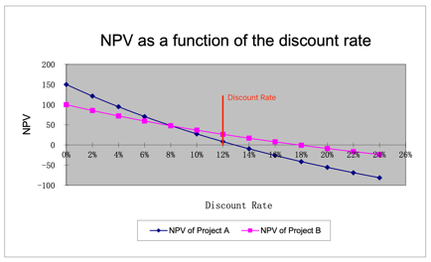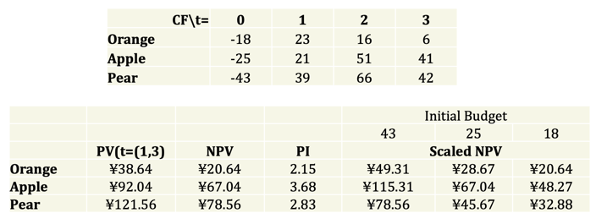

**(3) Profitability Index**. Profitability Index (PI) = PV/ I = (I+ NPV) / I (I denotes the initial investment; PV denotes the present value of cash flows that occur after the initial investment). Independent project: NPV>0, PI>1. Mutually exclusive projects: Do “higher NPV” and “higher PI” rules point to the same choice? **Not always**, PI ignores the size of investment; What if you have a tight budget and each project can be scaled up and down with constant PV per dollar? Then you should choose the project with the highest PI. **(4) Payback Period.** The amount of time required for an investment to generate cash flows to recover its initial cost. An investment is acceptable if its calculated payback period is less than some pre-specified number of years. *Disadvantages:* Ignores time value of money and risk differences; Requires an arbitrary cutoff point with no economic background; Ignores cash flow beyond cutoff date; Biased against long-term investment. *Advantages:* Easy to understand and simple to use; Adjusts for uncertainty of later cash flows by ignoring them; Biased toward liquidity (For firms relying on internal funds for new projects, emphasis on quick payback makes sense).

**3. Accounting Review. (1) Financial Accounting.** *Accrual 应计 accounting:* records revenue and expenses when transactions occur but before money is received or dispensed; *Cash flow calculation:* records revenue and expenses when cash related to those transactions is actually received or dispensed.  **(2) Balance Sheet.** *Features:* A snapshot of a firm’s financial position at one point in time; Assets are listed in order of decreasing liquidity (Ease of conversion to cash without significant loss of value); The balance sheet adheres to an equation that equates assets with the sum of liabilities and shareholder equity; Fundamental analysts use balance sheets to calculate financial ratios. *Assets for Non-Financial Firms:* Current Assets cash and other assets that are expected to be converted to cash within a year (Cash and Cash Equivalents; Accounts Receivable; Inventory); Non-Current Assets (Plant, Property, and Equipment (PP&E); Intangible Assets); Current Liabilities (Accounts Payable; Current Debt/Notes Payable; Current Portion of Long-Term Debt); Non-Current Liabilities (Bonds Payable; Long-Term Debt). Shareholders’ Equity (Share Capital; Retained Earnings). **(3) Net Working Capital.** = Current Assets – Current Liabilities. *Advantages:* An important component for calculating the company’s free cash flow. It measures a company’s liquidity and short-term financial health, indicating the ability to fund operations and respond to financial stress or opportunities. A consecutive of negative NWC is a implication for insolvency 破产. Often a key metrics in M&A 并购重组 deals. High working capital isn’t always a good thing. *Disadvantages:* It might indicate that the business has too much inventory, is not investing its excess cash, or is not taking advantage of low-cost debt opportunities. *NWC in M&A deals:* Why is NWC included in the purchase price? Working capital is necessary to maintain the ongoing operations of a business, so most sophisticated buyers include it in the purchase price when they submit an offer. This ensures they have enough working capital to operate the business post-closure and won’t need to inject extra money. NWC gives a buyer a clear idea of the level of capital required to keep the business running. Why a target? Working capital fluctuates for most businesses and is subject to manipulation. Agreeing on a target reduces friction between the parties by reducing the seller’s ability to manipulate it. The buyer and seller can agree on how much working capital to include in the purchase price without worrying about whether the actual amount will vary between signing the letter of intent (LOI) and closing. **(4) Market vs. Book Value.**

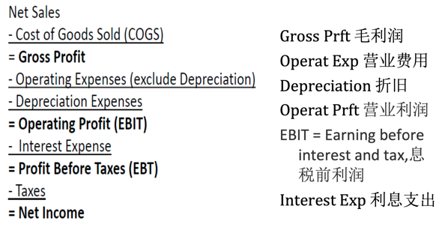 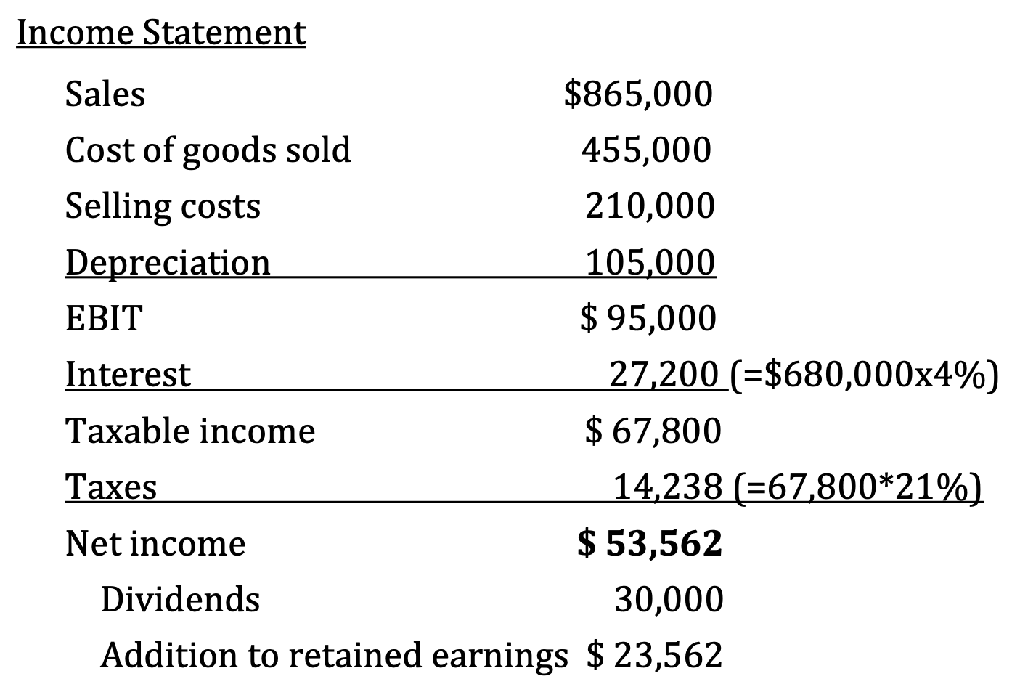 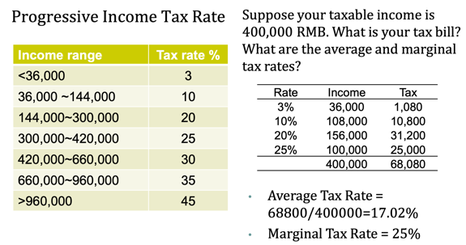

The balance sheet provides the book value of assets, liabilities, and equity. Market value is the price at which the assets, liabilities, or equity can actually be bought or sold. **(5) Income Statement.** A video of the firm’s operations for a specified period of time. Report revenues first, and then deduct any expenses for the period. During the year, the Senbet Discount Tire Company had gross sales of $865,000. The firm’s cost of goods sold and selling expenses were $455,000 and $210,000, respectively. The company also had notes payable of $680,000. These notes carried an interest rate of 4 percent. Depreciation was $105,000. The tax rate was 21 percent. Suppose the company paid out $30,000 in cash dividends. a) What was the company’s net income? b) What is the addition to retained earnings? **(6) Taxes.** Marginal rate: the percentage paid on the next dollar earned; Average rate: the tax bill/taxable income.

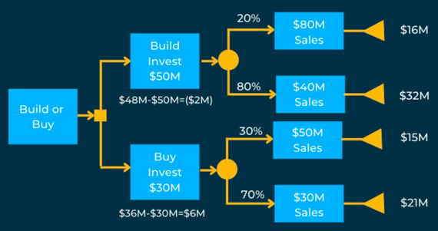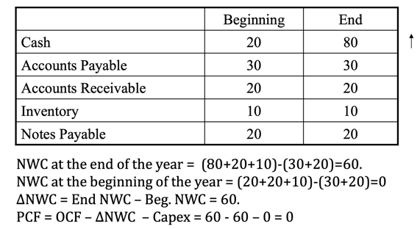**4.1 Project Cash Flow.** Identifying the right cash flows. **(1) Basic.** Think of project and company as separate entities, which were fully financed through equity. If in any year, project returned cash to company, then that is a cash ***inflow***. If in any year, project took away cash to company, then that is a cash ***outflow***. **PCF = OCF – Capex – ΔNWC** (OCF: Operating Cash Flow, Capex: Capital Expenditure, Δ NWC: Change in Net Working Capital (= cash + account receivable + inventory – account payable)) **(2) Three Ways to Compute OCF.** (S: sales, C: operating costs, D: depreciation, t: corporate tax rate). *The Top-Bottom Approach:* OCF = Sales - Costs - Taxes = (S - C) - (S - C - D) * t. *The Bottom-Top Approach:* OCF = Net Income + Depreciation = (S - C - D) * (1 - t) + D. *The Tax-Shield Approach:* OCF = (S - C - D) * (1 - t) + D = (S - C) * (1 - t) + (D * t) = (S - C) * (1 - t) + Depreciation Tax Shield. *Example:* What is OCF? Sales = $150, Cost of Goods Sold = $80, Depreciation = $30, Tax = 25%. The Top-Bottom Approach: OCF = Sales - Cost - Taxes = 150 - 80 - (150 - 80 - 30) * 25% = 60; The Bottom-Top Approach: OCF = Net Income + Depreciation = (150 - 80 - 30) * (1 - 25%) + 30 = 60; The Tax-Shield Approach: OCF = (150 - 80) * (1 - 25%) + 30 * 25% = 60. *Attention!* Depreciation is not a true cash flow. Interest is omitted due to separation of financing & investment considerations (has been in WACC. We do NOT subtract interest payment. Capital expenditures should exclude sunk costs that cannot be recovered). Taxes are calculated based on ACCOUNTING profit. **(3) Capex.** *Direct Method:* Amount spent on asset #1 + Amount spent on asset #2 + Amount spent on asset #3 - Value received for assets that were sold = Net Capex. (初期买为正，末期卖为负，卖的时候别忘了减税). *Indirect Method:* PP&E Balance in the current period - PP&E balance in the previous period + Depreciation in the current period = Net Capex. **(4) ΔNWC.** Changes in current assets and liabilities need to be considered to reflect true cash flow implications of sales or cost of production figures (Accrual Accounting: profits and expenses are recognized to match the business activity, instead of reflecting the cash flow.). ΔNWC = Current Assets - Current Liabilities, increase in NWC will lead to a drop in PCF to the firm. Cash is kept in the project as a buffer against unexpected expenditures. **(5) PCF to FCF.** The free cash flow has the same equation as PCF, only difference: ΔNWC does not consider **change in cash** as a part of ΔNWC. (PCF: cash is locked in the project, FCF: cash is part of the company’s valuation. The equity/debtholder could obtain this part of the value by selling their equity/debt). **(6) Key Issues of Capital Budgeting.** *Relevant cash flows* - the incremental cash flows associated with the decision to invest in a project. The incremental cash flows for project evaluation consist of any and all changes in the firm’s future cash flows that are a direct consequence of taking the project. Make the decision at the margin. *Decision tree analysis:* Nods (a decision/a probability event); Branches (different decisions (which decision you took)/different outcomes (what’s the probability of the event)); Solving the decision tree by backward induction (work from the end). **(7) Sunk Costs and Opportunity Costs.** *Sunk costs* are costs that have been incurred, and cannot be changed regardless of whether or not the project is undertaken; *Opportunity costs* are potential revenues that the firm missed out by taking the project (Assets in place to be used in the proposed project can be sold, leased, or used elsewhere). *Side Effects.* A project can have positive or negative side effects on other parts of the firm. (Negative) Erosion 腐蚀: A new product reduces the sales (cash flows) of the existing products. (Positive) Synergy 协同: A new project increases the sales (cash flows) of the existing products). *Treatment for different pitfalls.* Exclude: sunk costs (market studying cost); Include: opportunity costs of assets in place; Include: side effects (erosion, synergy, etc.); Include: investm ent in new net working capital; Exclude: financing items (WACC already). **(8) Example.** Suppose a project requires an investment of 1000, and will generate perpetual cash flow of 200. The discount rate appropriate for the cash flow is assumed to be 10%. The project is partially financed by perpetual debt. Risk-free rate is 5%. Debt raised is 200, and the interest rate is 5%. *Questions:* Should we deduct the interest payment of 10 to calculate the project cash flow? What is the NPV? *Answers:* An immediate problem of doing so is that the cash flow of 200 and the cash (out)flow of 10 do not have the same risk. The discount rate for the former is 10%, but that for the latter should be 5%. Thus, even if we subtract interest payment, it should be discounted at 5%. Thus, the NPV of the project is: NPV = (200/10%) - (10/5%) - (1000-200). This is the NPV calculated ignoring the financial items. NPV of financial transaction is zero in a frictionless world. This is the foundation of designing “project cash flow” as the



additional cash flow assuming the project was completely equity financed. **(9) Special Cases of Capital Budgeting.** Test Marketing; Termination Option; Externalities and Preemption; Equivalent Cash Flows; Equivalent Annual Cost (tax & depreciation). *Valuing projects with uncertainty (Real Option 实物期权).* When facing uncertainty, the flexibility to adjust investment decision when uncertainty is resolved is important. We need to value the flexibility inherent in a project. For example, option to expand — invest more in successful projects; option to abandon — cancel unsuccessful projects; timing options — when to invest in a particular project. When these options are valuable, a standard NPV analysis will **understate** the value of the firm, since it does not account for the options. Analyzing options: decision tree. Represent firm’s problem as a decision tree; Branches represent actions or outcomes; Nodes are points of time where either decisions are taken or different outcomes are possible; Solve the tree via backward induction: work back from the ends. Example. Suppose a company is considering a project whose cash flows could be either 100 with 50% chance, or 20 with 50% chance. The capital investment required is 50. If the company does the test marketing, it knows exactly what the cash flows will be. If it does not do the test marketing, it learns nothing new (that is, it does not revise the prior probabilities regarding cash flows). If test marketing costs $x, what is the highest possible value of x for which test marketing is worthwhile? Assume there is no discounting. Just like the decision tree, if the cost of test marketing is less than 15 (25 - 10), test marketing is a positive NPV project. Otherwise, it is a negative NPV project. *Termination Option.* A company is planning to introduce a new product in division A. The management thinks this is attractive because part of the machines of division B, which are idle, can be used. The current market price of equivalent machinery is 30 million. Other initial capital expenditure is 50 million. There are two scenarios possible. In the "good" scenario, which will occur with probability 0.5, the present value of remaining cash flows from this new project is 135 million. In the "bad" scenario, which will occur with probability 0.5, the present value of remaining cash flows is 20 million. *Which scenario prevails will be learnt shortly after the initial investment is made. The machines "on loan" from division B can be returned to division B at this time without any loss of their market value*. In the bad state, the project will be terminated, since the present value of the cash flows (20) is less than what the company would get by selling the machines from division B (30). Thus, the only "cost" to the company if the project is terminated is the 50m sunk investment. Therefore, NPV = 0.5 * (135 - 80) + 0.5 * (-50) = 2.5 > 0. **So the project should be taken!** *Externalities and Preemption.* A car manufacturer has determined that to prevent a competitor from introducing a new model that will lower its profits by $1000 per year for the next 10 years, it needs to introduce its own new model next year. This will require an investment today of $14,000, and the new model will generate sales of $3,000 per year for the next 10 years (and nothing thereafter). Cost of production will be $1000 per year. Of course, introducing its own new model will also lower the profits of its existing models. The company estimates that this reduction will be $500 per year for the next 10 years. Should the company introduce the new model if the discount rate is 10%? (Ignore depreciation, taxes, and working capital). Annual OCF for yrs. 1 to 10: = Sales - COGS - **Erosion + Profits Saved** =3,000 - 1,000 - 500 + 1,000 = 2,500. NPV = 2500(1-1/(1.1)10)/(0.1) - 14,000 = 15,361-14,000 = 1,361 > 0. Thus, the company should make the investment. *Equivalent Cash Flows.* Your company has to choose between two components 组件, A and B, which will reduce the operating costs. Component A costs $6m, lasts 5 years, and reduces operating costs by $1.5m per year. Component B costs $11m, lasts 7 years, and reduces operating costs by $2m per year. If a component wears out, you can replace it with a new one, with the same impact on cash flows. Which one will you 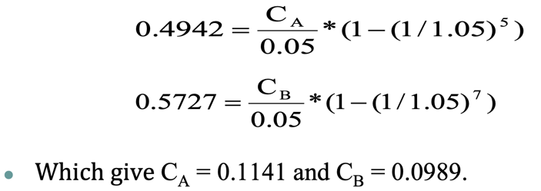choose, if the cost reductions are assumed "not risky" and the return on 5-year government bonds is 5%? Ignore depreciation and taxes. First, we find the NPV of each investment: NPVA = 0.49, NPVB = 0.57. **Should we choose B? NO!** Because the components have different lifetimes and can be replaced by the same model, we should compute the cash flow gain per year.This is the concept of ***equivalent annual cash flow***. We ask the question: for each component, ***how much annual cash flow per year does it add***? This annual cash flow is such that its present value over the life of the component is the same as the NPV of the component. Let CA denote this annual additional cash flow attributable to component A, and CB denote the corresponding number for component B, 这个地方就是将Cash Flow平分到各年份中, 做了一步反向计算. Based on the equation, we can get CA = 0.1141 and CB = 0.0989. Thus, component A gives the higher additional cash flow on a per-year basis, and should be chosen.

**4.2 Free Cash Flow.** **(1) Value a Firm.** The holders of the company’s stock and debt will get the cash flow of firm. *Way 1.* Value of a Firm (V) = Market Value of Equity (E) + Market Value of Debt (D). (E = NPV (cash flow to shareholders, cost of equity), D = NPV (cash flow to debtholders, cost of debt)), Issue: hard to separate the cash flows to equity and debt holder. *Way 2.* Consider the company as a whole. Value of a Firm = PV of the cash flows the firms is expected to generate now and in the future. Value of a company = NPV(CF, WACC). *Details.* Regarding the Company as a Project, free cash flow is the relevant cash flow. Free cash flow is generated from the firm’s continuing operations and is available for distribution (i.e., “free”) to the suppliers of capital (i.e., creditors, shareholders, etc.). Free cash flow is related to the firm’s business activities. It is unrelated to how the firm finances its operations. Free cash flow is the incremental *after-tax cash flows* the firm would generate *if it had no debt*. Source: financial statements. Complication: NI has deducted interest expense payment. **(2) Calculation of FCF.** *Direct method:* Starts with Cash Sales and restates the Income Statement to include only cash charges and operating cash flows. *Indirect method:* Starts with Net Income and adjusts for non-cash charges and non-operating cash flows included in Net Income; Same logic as the Bottom-Top Approach for OCF. We focus on the indirect method. **(3) NI to FCF.** Sales include: Sales on credit (account receivable), revenue earned but no cash received; Cost of goods sold: Include trade credit (account payable): expenses owed but no cash paid; Interest expense: A financing term, not an operating term; Taxes: Affected by tax deduction of financing term (e.g., interest) and non-cash terms (e.g., depreciation); *Questions.* Why are depreciation and interest treated differently? In a equity-funded company, depreciation has two effects on cash flow: Tax shield & Non-cash adjustment. Interest payment has only one: Non-cash adjustment. Why non-cash change in NWC? PCF: cash is locked in the project FCF: cash is part of the company’s valuation. The equity/debtholder could obtain this part of

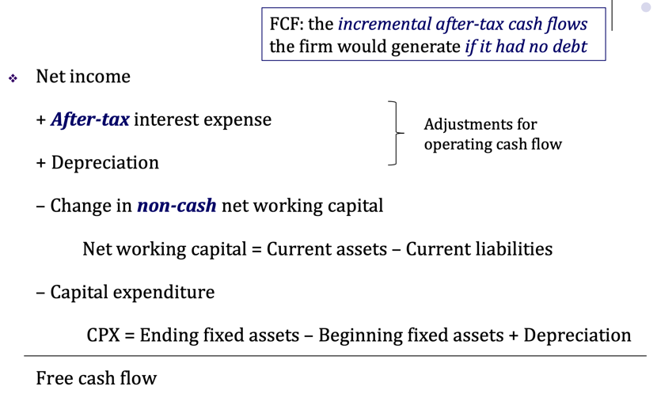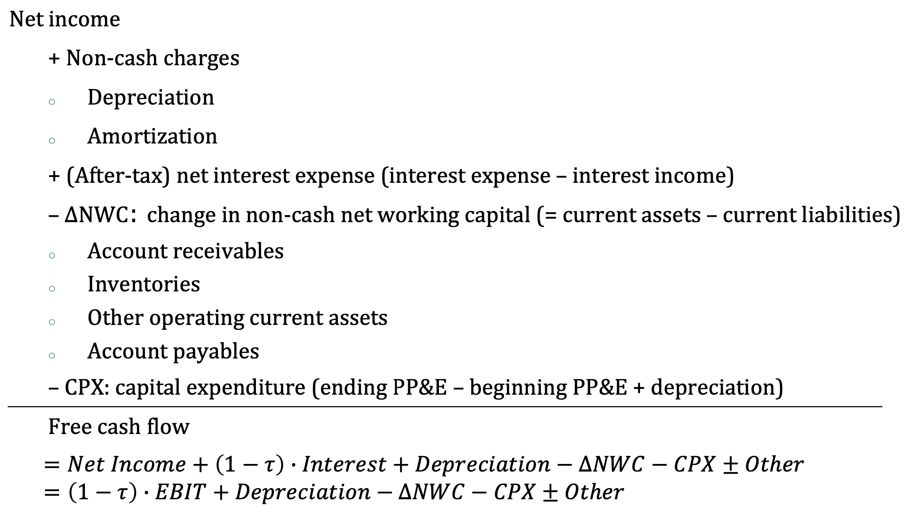

the value by selling their equity/debt. (**4) Example: NI to FCF.** The financial statements of a firm at the end of 2017 are given in the table on the next page. The effective tax rate of this firm is 40%. Compute *Net Income and Free Cash Flow* of this firm for 2017.

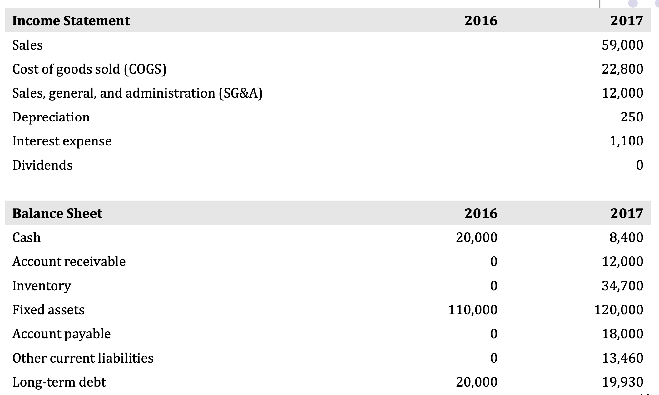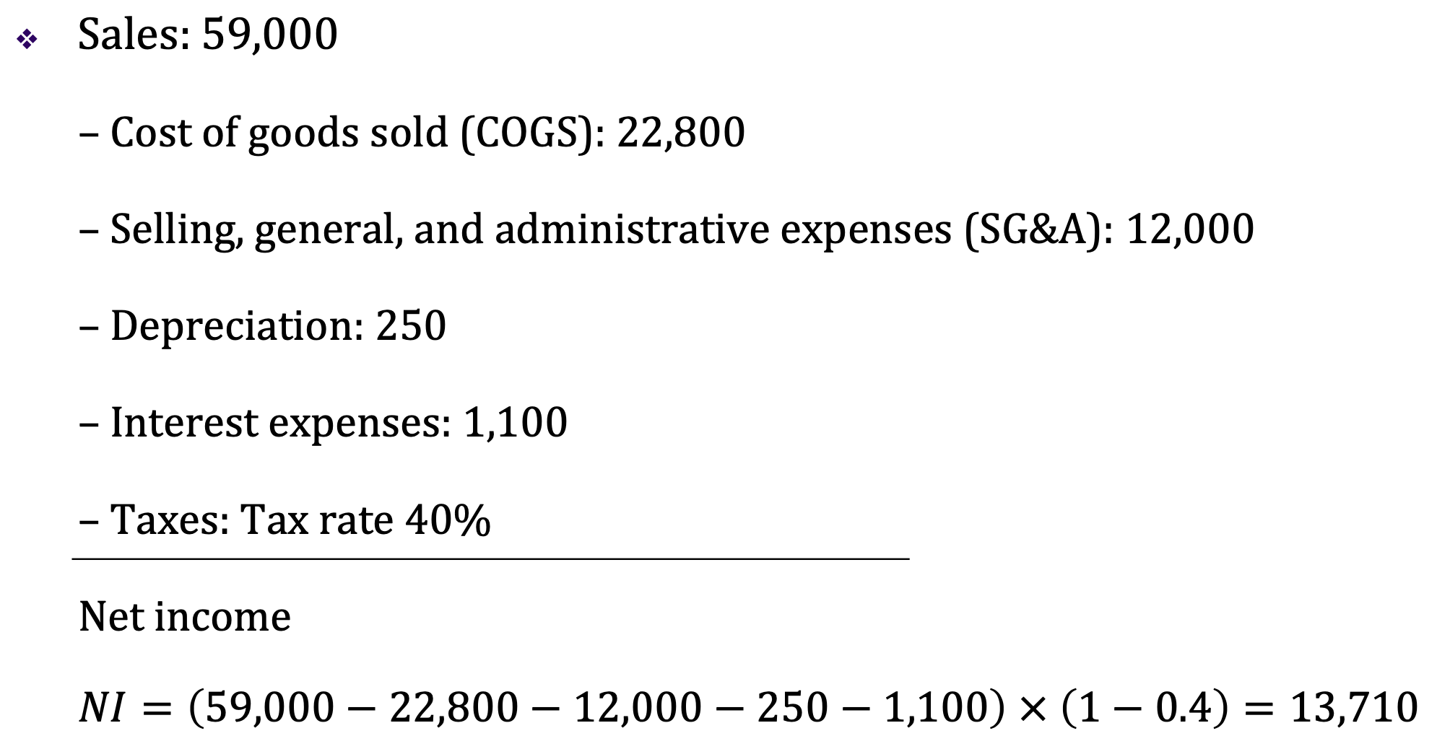

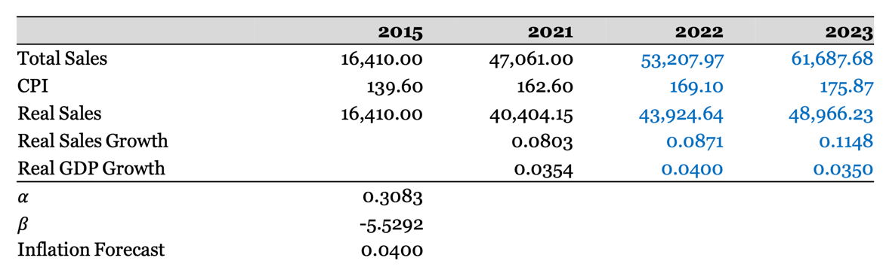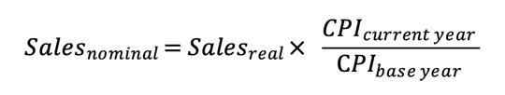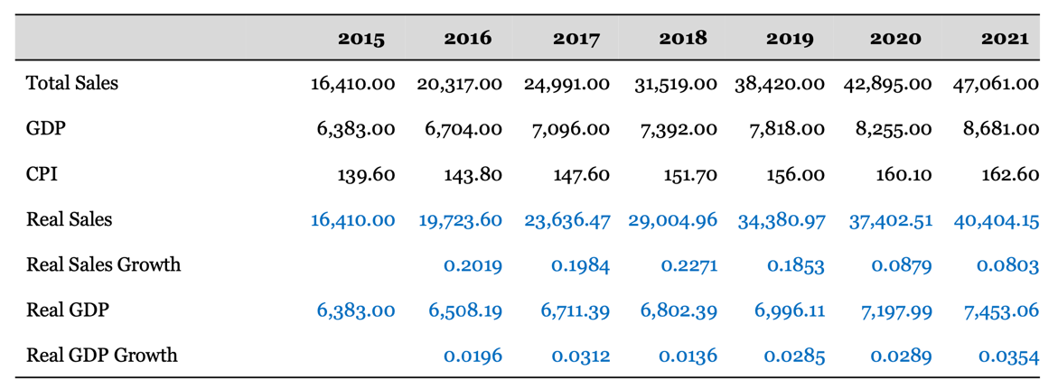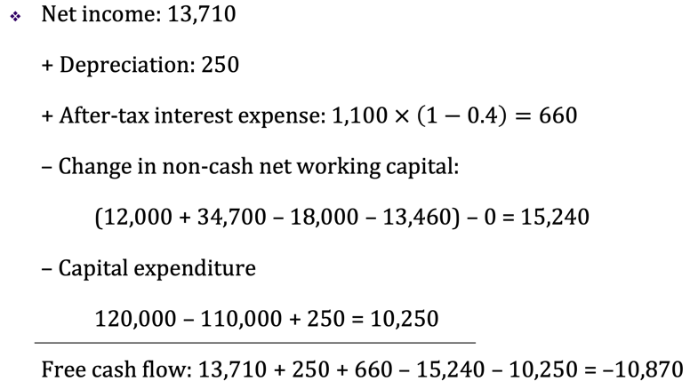**(5) Note: Statement of Cash Flows**. Companies report the accounting statement of cash flow. It records the sources and uses of funds, and reconciles cash balances. One item in the statement is called “Cash flow from operating activities”: It is NOT the same as FCF; It omits cash flows related to investment (Capex); It includes non-operating expenses and income (e.g., interest). **(6) The connections.** Free cash flows are the funds generated by the firm’s business (assets) and *are available* to pay the capital providers. Financial cash (out)flows are the funds *distributed* to the security holders of the firm. The difference between the two funds is the change in cash holdings over the period: Free cash flows = Financial cash (out)flows + ΔCash. *FCF<0:* Cash generated by operation is not enough to fund the new investment=>Financial CF<0 (raise new funds); Financial CF=0 (no external financing), ΔCash<0 (use up the existing cash holdings). *FCF>0:* Firm’s operation generates more cash than the required amount for investment=>Financial CF=0 & ΔCash>0 (retains more cash); Financial CF>0 (distribute to security holders). **(7) Conclusion of FCF.** We’re separating the investing and financing decisions and value the project/company as if fully equity financed => Simplicity, if not, multiple discount rates might be involved. Separation of the financing decision and the investment decision. **(8) Forecasting PCF.** *Pro forma (形式上的) financial statements.* Normally, we cannot directly forecast a project’s future cash flows, a common practice is to forecast the project’s pro forma financial statements. Pro forma financial statements are the project’s Balance sheet, Income statement, Statement of cash flow based on the forecast of the project’s future cash flows. *Sales forecast.* Many items in the pro-forma statements are closely related to sales. Sales forecast is the first step in the discounted cash flow (DCF) valuation and capital budgeting. Inflation adjustment. It is important to distinguish between nominal sales growth and real sales growth. Method 1: Regression forecasting. **Sale Growtht = 𝛼 + 𝛽 * GDP Growtht + 𝜀t**. Run a regression of real sales growth on real GDP growth. Eliminates the effect of inflation + Improves comparability across time + Better economic interpretation + Prices are not controlled by the managers. Method 2: Time series analysis. Sometimes, we examine past sales to identify trends that we expect to continue in the future. Linear growth cycle: **Real Salest = 𝛼 + 𝛽 * t + 𝜀t**. Exponential growth cycle: **Real Salest = e𝛼 + 𝛽 * t + 𝜀**.Method 3: Theoretical analysis. A firm’s **growth rate g** depends on: the percentage of reinvested earnings; the return earned on the firm’s reinvestments, e.g., return on assets (ROA). High growth firms typically have low payout ratio (high investment ratios) (Payout ratio, b = Dividends/Net Income; Reinvestment (retention) ratio = 1 - payout ratio = 1 - b). Low payout ratio allows these firms to reinvest in new projects, and grow faster. Example: In year 2017, a company has ROE of 9.76% and ROA of 4.18%. It paid out 46.38% of its earnings as a dividend. Suppose that ROA, ROE, and payout ratio stay constant: What is the growth rate that this company can achieve without issuing equity, but maintaining its current debt to equity ratio? g=ROE(1-b). What is the growth rate that this company can achieve without additional external financing? g=ROA(1-b). Forecast the firm’s sales by multiplying industry sales forecast to the projected market share. *Projecting operating costs.* We focus on cost of goods sold (COGS) and selling, general, and administrative expenses (SG&A). We can combine them in the forecast. If the company report depreciation as a component of these costs, we need to remove depreciation first from them. Different costs. It is important to distinguish between fixed and variable operating costs: variable costs (VC) are proportional to level of sales, fixed costs (FC) do not change with sales. It is not advisable to project operating costs (OC) as a fixed percentage of sales. Instead, OC = FC + (%VC) × Sales (%VC is the percentage of VC to Sales). Regression way. Consider a regression method: OC = FC + (%VC) × Sales. Set up the analog regression: **OCt = 𝛼 + 𝛽 × Salest + 𝜀**. Use past data to estimate coefficients 𝛼 and 𝛽: They will be the estimates of FC (𝛼) and %VC (𝛽), respectively. Attention. Using the regression analysis to project costs, we assume that firm’s cost structure will remain the same. What if firm was operating inefficiently in the past, but is planning improvements? One alternative is to use industry average estimates (analyze competitors). *Percentage of sales approach.* Many items in the income statement and balance sheet often vary depending on a firm’s (project’s) sales. If the ratios of these items to sales remain stable over time, then we can predict them once sales forecast is available. Use the past ratios to project future ratios and NWC items. We need to assume that these ratios are stationary over time. Projecting fixed assets. Fixed assets are difficult to project because although they depend on sales, the relation is not always linear. 1) Suppose the firm is currently operating its plant and machinery at 70% capacity, it can increase production and sales without adding fixed assets; 2) On the other hand, if it is operating at (close to) 100% capacity, it will need to buy fixed assets. Unfortunately, we do not observe utilization rates. ***Two types of capital expenditures***. Expansion of productivity capacity is undertaken when: Current capacity utilization is close to 100%, and/or Management is buying PP&E in anticipation of future sales growth. Maintenance of current productive capacity (replacement needs), it is not equal to depreciation, which is an accounting concept. Projecting expansion of capacity. 1) GFA turnover = Sales/Gross fixed assets. (examine how this ratio varies over time, compare firm’s GFA turnover with that of its competitors); 2) Useful clues on firm’s capacity utilization. 3) Suppose capacity utilization is almost 100%. (firm needs new assets to generate new sales, projected GFA = Projected Sales/GFA Turnover). 4) Note: A firm can add new capacity even when it is operating less than 100% capacity. Why? In anticipation of future growth. Therefore, always read firm’s “Annual Report” to find out the firm’s capital expenditure plans. 5) Example. A firm had sales of $1 million. The GFA turnover for the firm is 1.35, while comparable firms in the industry have a GFA-turnover of 1.70. Compute the maximum sales the firm can achieve without expanding capacity? Assume that comparable firms are operating at 100% capacity utilization. **$1 million/1.35*1.7**. Projecting replacement of capacity. This information may be found from the “Notes to Financial Statements”. Simple (crude) method: 1) For all past years, find out how much CPX was for replacement of productive capacity; 2) Compute past growth rate of the replacement CPX; then its average. 3) Assume that, in the future, CPX needed for replacement will grow at this average growth rate. *Other aspects of forecasting.* To be able to make accurate forecasts, we must understand the operating and financial characteristics of the firm. Ratio analysis helps understand these characteristics (Liquidity, Leverage, Asset use or efficiency, Profitability).

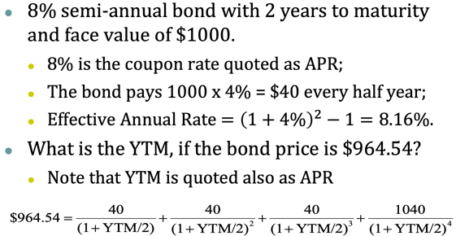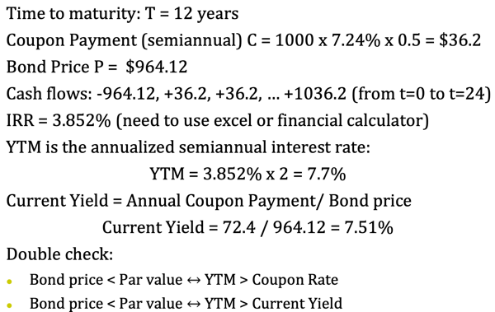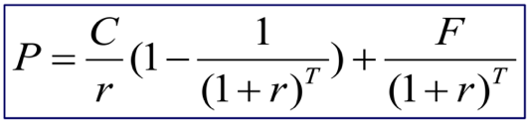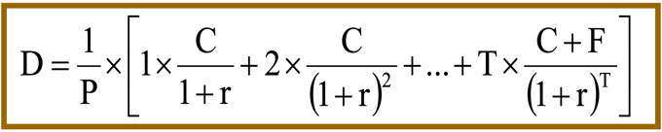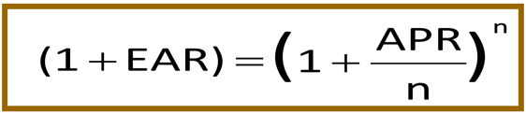**5. Bond Valuation. (1) Key Points.** Return, expected return, and discount rate. *Return.* Suppose price of a financial asset today is P0, Buying the asset costs P0. At the end of the year, I get a cash amount C1 and the price of the asset is P1. Return = (C1+P1-P0)/P0 = C1/P0+(P1-P0)/P0. Return = Cash Yield + Capital Gain Yield. *Expected Return.* Expectation of future return from the investment, i.e. C1 and P1 are in “expected terms”. Expected Return=E(C1+P1-P0)/P0=E(C1)/P0+(E(P1)-P0)/P0. Expected Return = Expected Cash Yield + Expected Capital Gain Yield. Expected return is the same as the discount rate for the asset’s cash flows. *Discount Rate.* = Expected Return. P0 = (E(C1) + E(P1)) / (1+r), where r is the discount rate, and is the definition of expected return, which is **the cost of capital**. **(2) Determination of discount rate.** *Time value of money.* *Inflation.* 1 + Nominal Interest Rate = (1 + Real Interest Rate)*(1 + Inf). *Risk.* **(3) Bond.** A bond is a debt instrument requiring the **borrower** (i.e., issuer) to repay to the **lender** (i.e., bondholder) the amount borrowed (principal) **plus interest over a specific period of time**. The bondholder generally receives **a fixed interest payment (coupon)**, each period until the bond matures. *Lingo.* **Face value/par value/principal (F)** is the amount of a bond that is repaid at the maturity. **Coupon (C)** is the regular interest payment until maturity. **Coupon rate** is the annual coupon payment as a percentage of face value (C/F). **Maturity (T)** is the specified date on which the last payment (face value) on the bond is made. **Price (P)** is the traded value of the bond. *Bond Price.* Bond price is the present value of all cash flows discounted at the required rate of return. (semi-annual 半年付息, zero-coupon 零息债券) *Yield to Maturity (YTM).* YTM is the discount rate used to price the bond. YTM is also the expected return of investing in the bond. Find the discount rate from the price of bond. 1) Note that P is observed from the market, C is contractually fixed, and the time to maturity “t” is also known. 2) One can then solve for the discount rate => called YTM. 3) Excel: **IRR(-P,C,C,C…,C+F)**. For a company planning to raise capital by issuing bonds, the YTM is the relevant cost of debt. Other interest rates of a bond: Current yield = C/P; Coupon rate = C/F. The relationship: If a bond is selling at par (P = F), YTM = Current Yield = Coupon Rate; If a bond is selling at a premium (P>F) or discount (P<F), the YTM is different from the current yield and coupon rate. YTM vs. Current Yield: Expected return = Expected Cash Yield + Expected Capital Gains. YTM = current yield, only if the expected capital gain = 0. *This is only true if a bond is selling at par (P=F)*. Relation between P and F: 1) Selling at par (P=F), if YTM=current yield; 2) Selling at a premium (P>F), the expected capital gain is negative, and current yield > YTM. 3) Selling at a discount (P<F), the expected capital gain is positive, and current yield < YTM. (这些结论在期限为 1 的情况下都很好推导). YTM vs. Coupon Rate: If P>F, then Coupon Rate>YTM. P vs. F: Most bonds are issued at par, at issuance, YTM=CouponRate & P=F. After that, C, F, & T are fixed, but r changes, P moves. Zero coupon bonds always trade below par. If bond’s risk does not change, as maturity date approaches, the price of the bond approaches the face value. *Interest Rate Quotation.* Annual Percentage Rate (APR, 实际给出的每年利率). Effective Annual Rate (EAR, 分期收利息之后的实际利率). 注意这个地方 YTM 很 Trick, 直接按照年分几次进行平分就可以了！ **(4) Risks that Affect Bond Yields and Prices**. *Credit Risk.* The risk associated with the issuer failing to satisfy the terms of the obligation with respect to the timely payment of interest and face value (越高的风险，越低的价格). Two determinants. Probability that default occurs. Recovery rate (salvage value for bondholders, Depends on bond characteristics (seniority, collateral, etc.) and the type of firm’s assets). YTM = Risk-free Rate + Credit Spread. Credit spread determined in the market. In practice, often reference credit spread for similarly risky bonds. The higher credit risk, the higher credit spread (bond rating). *Interest Rate Risk.* The fluctuation in financial asset prices due to **changes in interest rates**. This risk is present even if the bond issuer has no default risk. Different bonds are affected differently (Long-term bonds more risky than short-term bonds, Low coupon rate bonds more risky than high coupon rate bonds). Duration measures the % change in bond price for a 1% change in the yield. 求导做比就可以了，具体公式见图片(分母有 * 1 + r)。

**6. Stock Valuation. (1) Basic Concepts.** Stock holders are entitled with Dividend Payments. Stock does not have maturity (除非公司破产). Secondary Stock Market. *Fundamental valuation:* Valuation derived from fundamentals (cash flows, growth rate, risk, etc.) Dividend discount model, CAPM. *Relative valuation:* Valuation based on the market valuation of similar or comparable assets. Also called multiple valuation. **(2) Dividend Discount Model:** The value of a stock is the present value of future expected dividend per share. *A preferred stock* promises a fixed dividend per share every time the company pays a dividend. Hence, the price of a preferred stock is $P_{0}=\sum_{t=1}^{∞}{\frac{D}{{\left(1+r\right)}^{t}}}=\frac{D}{r}$. *A common stock* is not associated with any fixed dividend obligations. If dividend per share is expected to grow at the rate *g* per year, then the Gordon growth formula (the growing perpetuity formula) can be used to derive $P_{0}=\sum_{t=1}^{∞}{\frac{D_{0}{\left(1+g\right)}^{t}}{{\left(1+r\right)}^{t}}}=\frac{D_{0}\left(1+g\right)}{r-g}$. *g = retention ratio (Mt/Et) * ROE = (1- payout ratio) * ROE.* As with any financial asset, the discount rate for a stock is also the expected return to investors who buy the stock. r = D1/P0 + g: Expected return = expected cash yield + expected capital gain yield. Thus, the stock price is expected to appreciate at the same rate as the 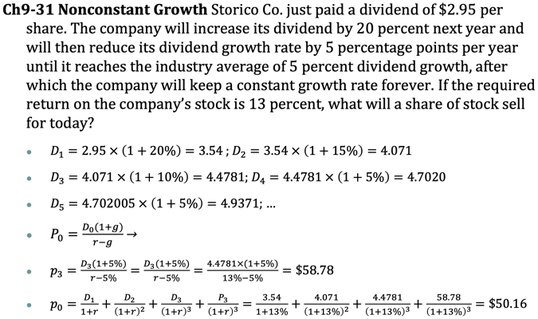growth of dividends or earnings (under a fixed payout rate). *Drawbacks of DDM:* Only applicable to the firms with (steady-growing) dividend payments. (Some companies don’t pay dividends. Won’t apply to companies whose growth rate is not constant). The risk of cash flows is not explicitly spelled out – hard to link the risk to the formula. **(3) Relative valuation:** S1. Identify comparable firms/assets (Similar activity, industry, size, etc. To make sure similar risk, growth, cash flow characteristics). S2. Convert market values to standardized values by constructing multiples (Absolute market prices cannot be directly compared). S3. Compare the multiple for the asset being analyzed (Control for the differences). *Multiples.* The commonly used multiples include: Earnings multiples. PE 市盈率 (Price/Earnings Ratio), PEG (PE / expected growth in earnings), Enterprise Value / EBITDA (Enterprise value 企业价值 = Market capitalization市值 + Debt– Cash holding). Revenues multiples. Enterprise Value/Sales, Enterprise Value/Customers. Book value multiples. Market Value of Equity/Book Value of Equity, Enterprise Value/Book Value of Assets, Tobin’s Q (Tobin’s Q = Total market value / Total book value of the firm). *Relative Valuation is Pervasive.* Although DCF is more common in consulting and corporate finance, multiple valuation can be good complement. DCF may be used to back into a number obtained by multiple. The terminal value for cash flow valuation may be estimated using multiples. Why Pervasive? Relative valuation is likely reflecting the market perceptions. Important in IPO and acquisition markets (Since portfolio managers are judged by how they perform relative to other managers, relative valuation is more tailored to their needs). Relative valuation generally requires less information than discounted cash flow valuation. It could be applied as a screener. *Practical Issues.* Ideally, as many as possible comparable publicly traded firms. In practice, it is very difficult (and perhaps impossible) to find firms that share the same risk, growth, cash flow, capital structure, payout policy, etc. Consistency. Same methods to estimate inputs (Historical P/E, based on last fiscal year’s earnings; Trailing P/E, based on earnings of last four quarters; Forecasted P/E, based on consensus forecasted earnings for the next fiscal year). Same accounting methods. (Diluted vs. non-diluted P/E, Diluted EPS is based on the number of shares assuming all the convertible securities and employee options have been exercised). Distribution. Check the cross-sectional distribution of the multiple to judge whether a particular value is too high or low. Private Firms – Adjustments. Control premium: (Might be as high as 25 – 50%) Public firm stock is traded in small stakes, while private firm transactions often involve a change in control. Control allows changing managers, setting their pay, determining firm’s payout policy, even its strategy. Marketability discount. Takes time to find potential buyers of shares. Alternatively, you can use multiples from past deals. Recent transactions of the same type and similar firm. But “no asset gets sold twice in the market, for it’s not the same market and the asset is not the same asset”. Sometimes there is a long time between transaction and valuation date, so be alert to the changing risks and growth expectations. Market May be Wrong. In a relative valuation, you are only concluding that the stock is undervalued/overvalued compared to the market. Multiples are certainly useful if market perception is what you actually need.

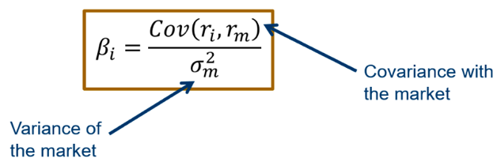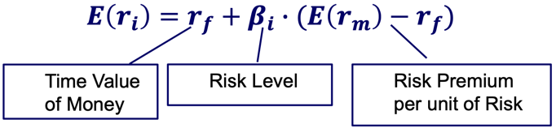**7. CAPM.** Required rate of return = Compensation for the time value (risk-free rate) + Compensation for risk (risk premium). Capital Asset Pricing Model (CAPM) computes that the risk premium is equal to the multiplication of the level of risk 𝜷𝒊 and the required return that is charged by the investor for each level of risk (**E(rm)-rf)**. **(1) Risks.** standard deviation of the return 𝜎(𝑟) is the risk; The returns of individual assets in a portfolio do not always move in the same direction, they cancel each other and reduce variability of the portfolio. Any point on **tangent** line (Capital Market Line) gives the same Sharpe Ratio, which is the highest possible Sharpe Ratio one can achieve in this capital market (在该线上进行市场组合资产以及无风险资产的组合). *Diversifiable (unsystematic) and non-diversifiable (systematic).* Diversifiable risk: risks that can be mitigated through investing in other financial assets/companies/countries. **Diversifiable risk is not compensated.** Undiversifiable risk: risk that cannot be eliminated through diversification (market risk, such as economic recession). Here in CAPM, we show that securities with undesirable features (high market risk) have a higher return. *Measuring the undiversifiable risk: beta.* A measure of firm’s systematic risk: its sensitivity to market portfolio returns. Beta essentially is the regression coefficient of the assets’ return on the market return (can be positive, negative, lager than 1 要会通过标准差相关性算协方差) *Explain for CAMP.* 𝛽𝑖 reflects **asset i’s quantity of systematic risk**, i.e., the sensitivity of return to market return. 𝐸(𝑟𝑚-𝑟𝑓) is also called **Market risk premium**: the required return for bearing one unit of market risk. **(2) In Practice.** *Risk Free Rate.* Use the current yield on the long-term government bonds. 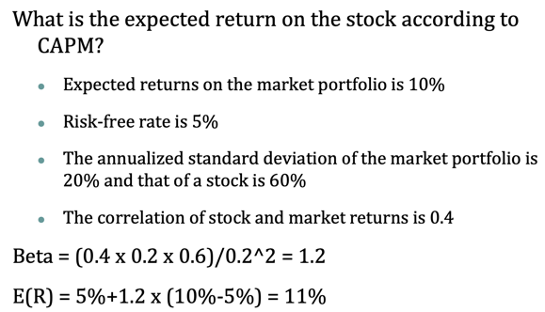*Market Risk Premium.* Portfolio of all risky assets (stocks, bonds, etc.) traded in capital markets (S&P 500, CSI 300). Features. Hard to tell; Anything between 3% and 8% could be justified; May vary across countries; *Betas.* Get it from somewhere like Bloomberg/Reuters/Yahoo Finance. Compute yourself using past stock returns and market returns Analysts typically use a **5-year time horizon**, and **monthly returns** to compute the betas. Subject to statistical error. *Caveat.* CAPM relies on strong simplifying assumptions (Diversified investors, Observability of market portfolio, Constant beta, No arbitrage condition). Multi-factor model, risk-factors other than market risk can also be non-diversifiable and thus are priced. Similar to CAPM, look at the covariance between stock performance and some portfolio’s performances (Long companies with high metrics, short companies with low metrics). Debt-to-equity ratio. Beta is a function of capital structure, if the capital structure changes, beta changes.

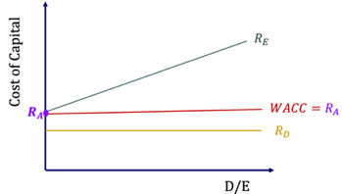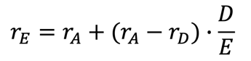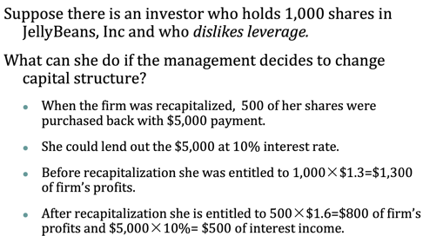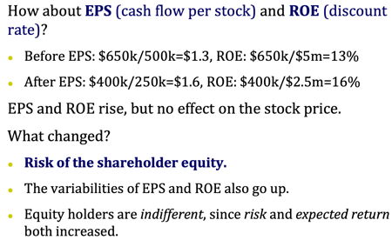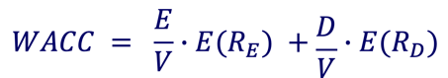**8.1 MM(without tax). (1) Cost of Capital.** A weighted average of the cost of debt and equity. Equity is more risky than debt. 那是不是意味着全部用债更好, 成本更低? Not Necessarily! Equity is riskier than Debt. This is why the return on equity should be higher than on debt. **(2) M&M Theorem Proposition I.** Without frictions, the Value of the Firm does NOT depend on its Capital Structure. Firm value is like a pie (stems from cash flows assets generate; then split between debt-holders and stockholders) 不管怎么分, 大小不变, 调整资本结构无法影响大小. *What does No Frictions mean?* No tax shield (no taxes, or interest is paid after tax); No consequences of finan-cial distress for assets (破产没影响); Well functioning financial markets (Individuals can borrow and lend at the same rate as corporations, no info asymmetry and agency frictions). *Logic.* 在资本结构改变的情况下Debt的成本不变, 但是Equity的成本会随着Debt的增加而增加, 最终导致资金成本不变. 上课推导的逻辑是先假设资金成本不变（因为资金成本只和现金流产生的风险相关）, 会发现Equity成本改变. *Punchline.* Capital structure is irrelevant as long as it does not affect the total cash flows generated by the assets. Investors can achieve the payoff from their desired capital structure using homemade leverage. *More Intuition.* In the Jellybean Inc. example, leverage goes up and the equity becomes more risky and the return on equity increases, **𝛽 also increases 𝜷𝑬 = 𝛽𝐴 + 𝐷/𝐸(𝛽𝐴−𝛽𝐷).** (Beta of the firm’s assets depends on the risk of firm’s cash flows. In absence of frictions, cash flows do not change with leverage level). The Beta of firm’s cash flows is the firm’s Asset Beta (It is also the beta of the Equity of a firm with No Debt, since Asset=Equity if the firm had no debt. Thus, it is also often called the Unlevered Equity Beta.). **(3) M&M Theorem Proposition II.** The expected return on equity of a levered firm **increases** in proportion to leverage. 𝑟𝐴 the return on assets if the firm had no debt. Any increase in expected return is exactly offset by an increase in risk. Firm value does not change with leverage in absence of taxes and other frictions. *WACC is the discount rate for firm’s cash flows. WACC=rA. RA*, *RD*, *RE* 关系如右.

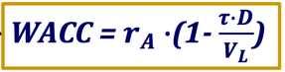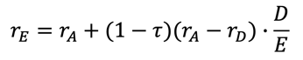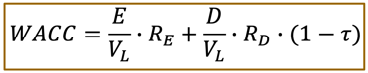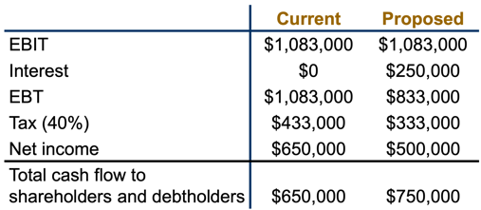**8.2 MM(with tax). (1) Taxes.** 开始抹除第一个假设, 引入税收. By replacing some equity with debt, a firm would pay more in interest (less in dividend), but less in tax payments. The total cash flows to equity and debt holders are larger by the amount of tax saving. So, the value of a levered company is greater than that of a unlevered firm. Notice that we are assuming taxes only affect the distribution of cash flows, but notthe FCF generated from the firm’s continuing operations. **(2) Proposition I.** Firm value increases with leverages. 𝑉𝐿=𝑉𝑈+𝑉t (where 𝑉𝐿 is the firm value with debt (levered firm value), 𝑉𝑈 is the firm value without debt (unlevered firm value), 𝑉𝑡 is the present value of all future tax shields of interest payments.) *Tax shield.* 𝜏*Interest=𝜏*(𝑅𝐷*𝐷). PV of tax shield=𝜏*D. Discount rate for tax shield is the expected return on debt (The risk of the tax saving on interest has the same risk as the interest on debt itself). *Considering Taxes.* 𝑉𝐿 = 𝑉𝑈+𝑉t = 𝑉𝑈+𝜏×𝐷. Value of tax shield is increasing in debt level, so is the (levered) firm value. Find the unlevered firm value, 𝑉𝑈, first. Free cash flow is the after-tax cash flow a firm would generate if had no debt. So, FCF is the unlevered cash flow for 𝑉𝑈. Return on asset of full-equity firm (𝒓𝑨) is the discount rate. 𝒓𝑨 is independent to leverage. **(2) Proposition II.** The expected return on equity of a levered firm **increases** in proportion to leverage (D/E). 这个地方很make sense: 因为有税盾D增加带来的风险没那么大了. Discussion: As debt increases, the risk of cash flows remains the same (𝑅𝐴 is a constant), but the risk of equity (𝑅𝐸): Increases because a higher fraction of fixed cash flows to the debt holder; Decreases because tax shield

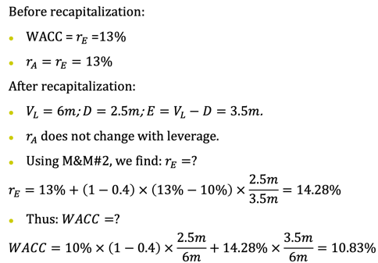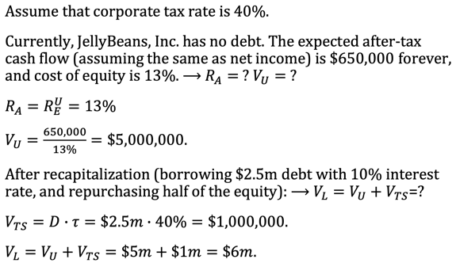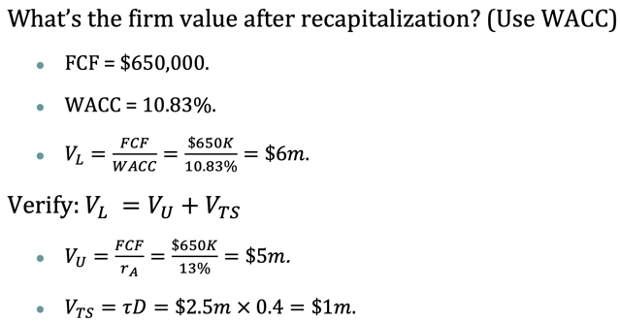

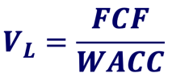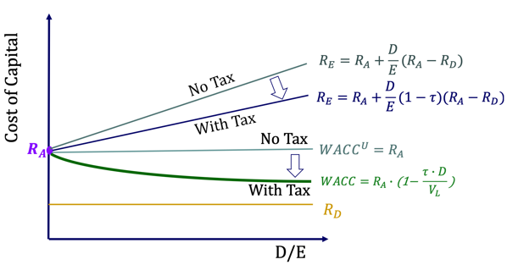goes to the equity holders and tax shield is less risky than the general cash flows. The net effect of leverage on equity risk is (𝑟𝐴− 𝑟𝐷)(1−𝜏). **𝜷𝑬 = 𝛽𝐴 + 𝐷/𝐸(1-𝜏)(𝛽𝐴−𝛽𝐷).** Tax shield r educes the effective cost of debt by a fraction of the marginal tax rate. WACC<rA. WACC and Firm Value. Firm value is the total unlevered cash flows discounted at the WACC of a levered firm. FCF is generated from operations and is free to be distributed to capital suppliers. FCF doesn’t change with leverage.

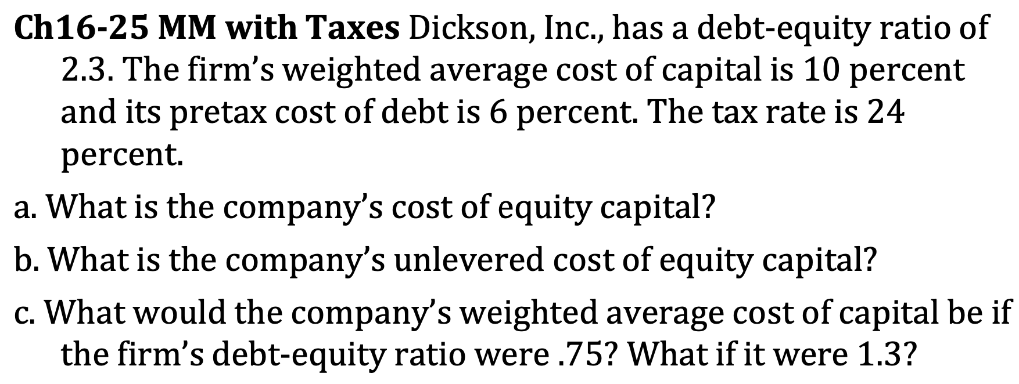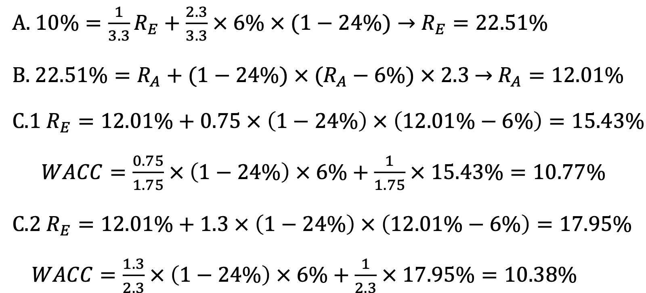

**9.1 Valuation for Levered Firms. (1) Three Approaches.** *1) Adjusted Present Value: APV = NPVU + NPVF*.The value of a project to the firm can be thought of as the value of the project to an unlevered firm (NPVU) plus the present value of the financing side effects (NPVF). There are four side effects of financing: The Tax Shield of Debt; The Costs of Issuing New Securities (flotation costs); The Costs of Financial Distress; Subsidies to Debt Financing (borrow at tax-free rate from government). *2) Flow to Equity Approach.* Discount the cash flow from the project to the equity holders of the levered firm at the cost of levered equity capital, 𝑟𝐸. There are three steps in the FTE Approach: Step One: Calculate the levered cash flows (LCFs, LCF = FCF – After-tax Interest Expenses, FCF=(S-C-D)x(1-t)+D-Capex-ΔNWC); Step Two: Calculate 𝑟𝐸. Step Three: Value the levered cash flows at 𝑟𝐸. *3) WACC Approach (most).* To find the value of the project, discount the unlevered cash flows (free cash flow) at the weighted average cost of capital.

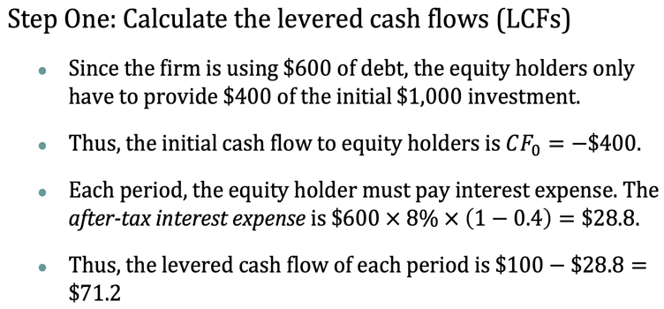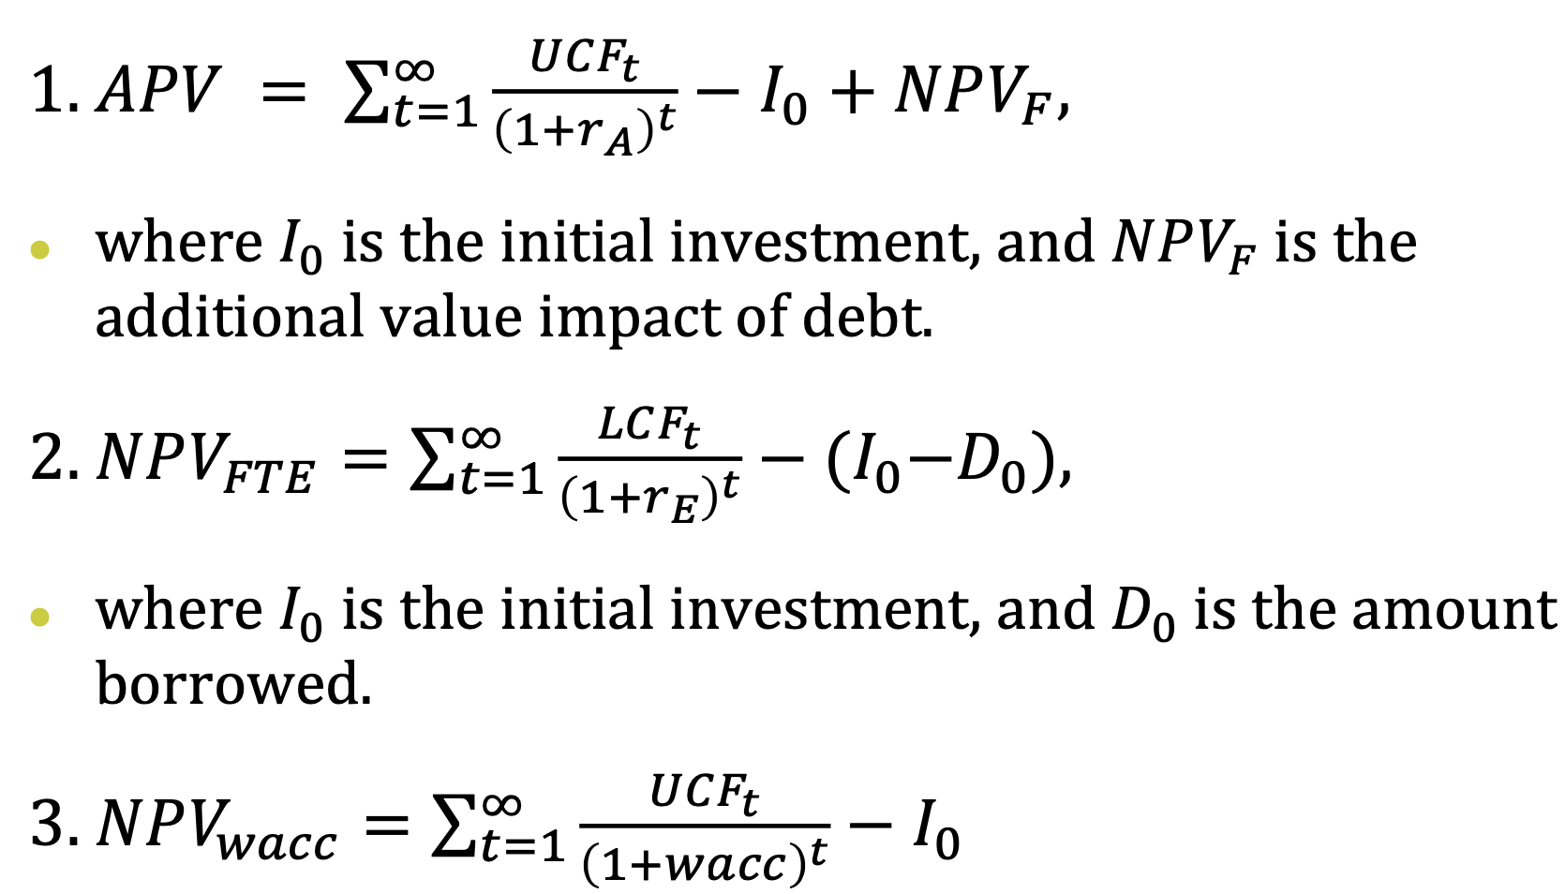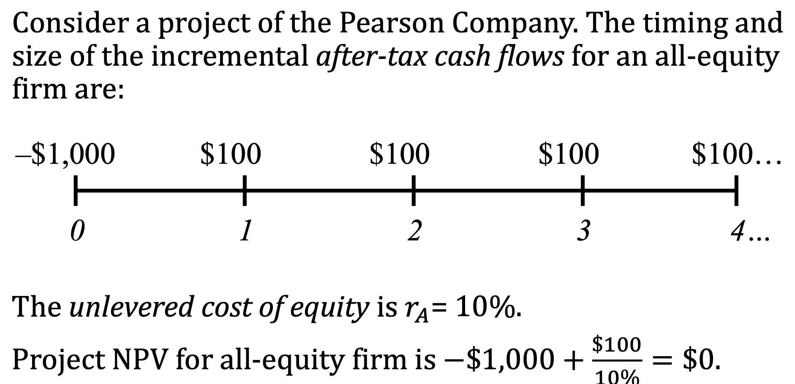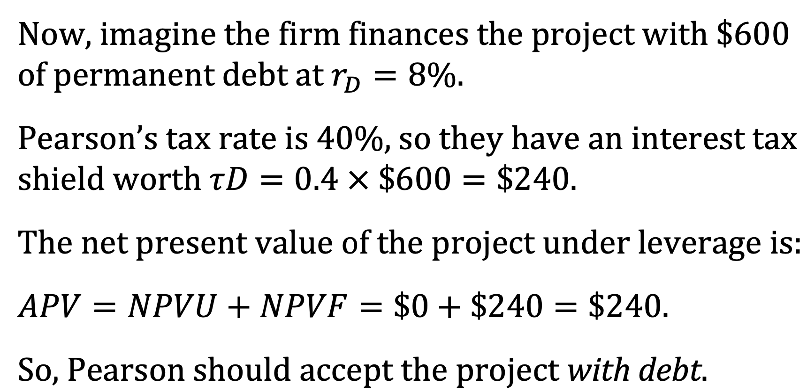

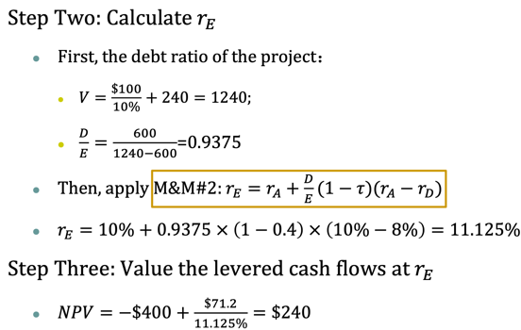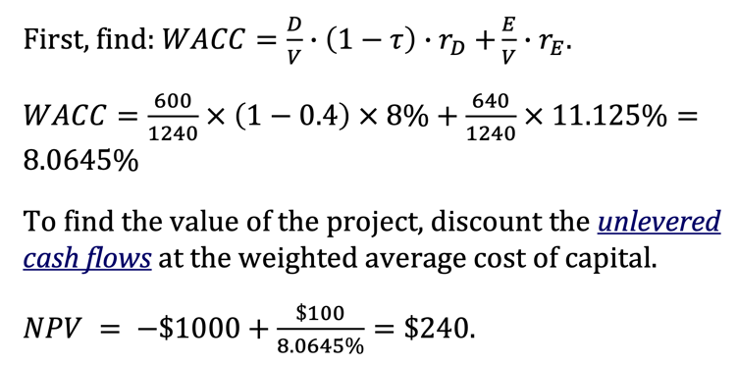Three approaches can also be applied to capital budgeting problems for the projects with non-perpetual cash flows(WACC is the most commonly used by far. FTE has appeal for a firm deeply in debt. APV is used if the level of debt is known over the project’s life, APV is frequently used for special situati ons like LBOs and leases.). They might not give the exact same valuation. **(2) Details of Estimating WACC.** We need to know the expected return on equity, expected return on debt, and expected capital structures to compute WACC (Tax rates: If you are a passive analyst, use firm’s current tax rate; If you are a decision maker, use marginal rather than average tax rate). *At Target Capital Structure.* One can directly plug the current debt ratios into the WACC formula. The cost of debt can be represented by the yield-to-maturity of corporate bonds outstanding. If the company has no bonds trading, one could look for the YTM of a company with similar default risk in the same industry. Default risk could be measured using Altman’s Z-score. For the cost of equity, one can apply the CAPM. *Changing Capital Structure.* However, if the recent capital structure is very different from the target cap. 结构变了, *RE*没有参考性, 借助*RA*. If we know expected 𝑟𝐴 and the targe t level of 𝐷/𝑉, we can find out WACC under the target capital structure.

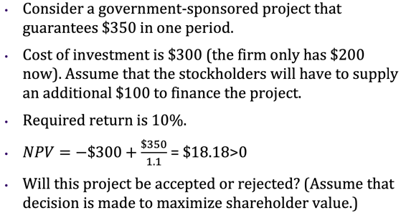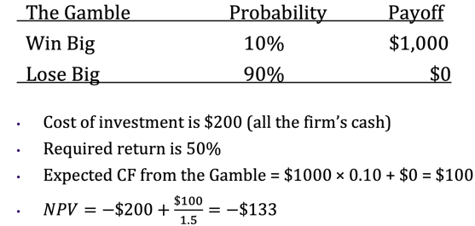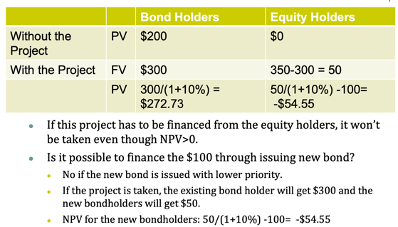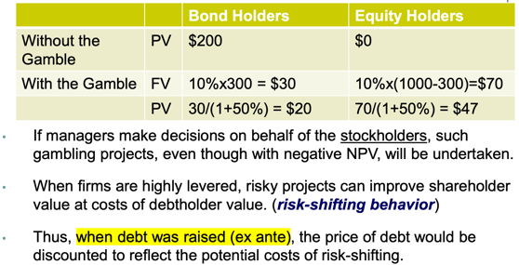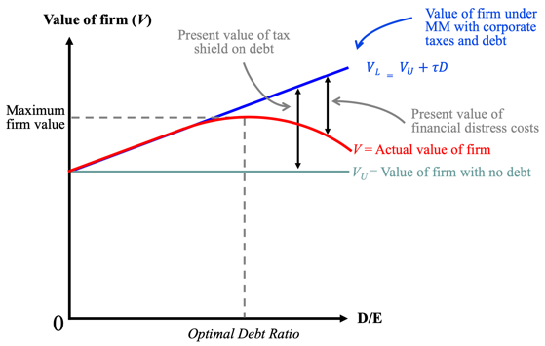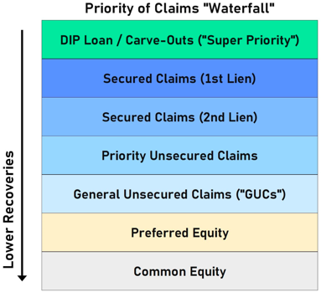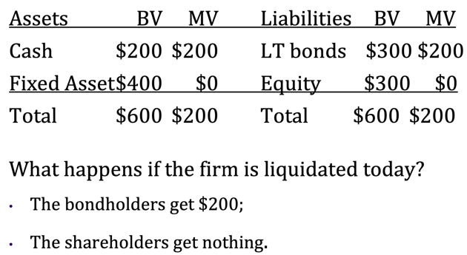**9.2 Limits to the Use of Debt.** MM(with tax) 表示D占比越大越好, 但实际生活中没有债务100%公司, 还有需要考虑的地方. **(1) Default.** *Definition.* A default/insolvency occurs when a borrower fails to make required interest or principal payments on a debt. Bankruptcy 破产: a legal proceeding initiated when a person or business cannot repay outstanding debts or obligations. Liquidation 清算: bringing a business to an end and distributing its assets to claimants. *Attention.* Default does not lead to bankruptcy immediately. Bankruptcy does not necessarily lead to liquidation. What happens after default? Reorganization. **(2) Cost of Distress.** If debt ratio is too high, the firm might run into trouble if, say, recession hits. Capital structure is irrelevant as long as it does not affect the total cash flows generated by the assets. Default does not lower firm value (Default changes the ownership, not the cash flow of the firm). But the possibility of bankruptcy has a negative effect on the value of the firm. There might be direct and indirect costs associated. *Direct costs (at default).* Legal and administrative expenses: The bankruptcy process is complex, time-consuming and costly. Costly outside experts are often hired by the firm to assist with the bankruptcy process. Creditors also incur costs during the bankruptcy process. They may wait several years to receive payment. They may hire their own experts for legal and professional advice. Fire sale, loss of intangible assets. Affect. The direct costs of bankruptcy reduce the value of the assets that the investors will ultimately receive. The average direct costs of bankruptcy are approximately 3% to 4% of the pre-bankruptcy market value of total assets. *Indirect costs (before default).* Poor operating decisions while firm is financially distressed (Agency costs of debt); Because of the uncertainty about the future, the firm may lose customers, suppliers or key employees. Affect. A firm need not to enter bankruptcy to suffer the indirect costs of financial distress. They are often much larger than direct costs of bankruptcy. It is estimated that the potential loss due to financial distress is 10% to 20% of firm value. Loss of Customers, Suppliers, Employees, Receivables, Costs to Creditors Due to Conflict of Interest (Shareholder vs creditors). *Risk Taking Example.* 给出了一个NPV为负, 但是还是要执行的例子(能增加股东收益). *Underinvestment Example.* 给出了一个NPV为正, 但不能执行的例子(不能增加股东收益). With senior debt in place, firms may not be able to raise capital for new investments, because all the additional value goes to the existing (senior) debt holders. Thus, positive NPV projects may be forgone. This is called the debt-overhang problem. 如果不使用发股融资而是继续向现存的债主借债, 比如再借100, NPV只要是正, 项目就还是可以执行的! *Milking the Property 榨取资产.* Liquidating dividends: Suppose the firm paid out a $200 dividend to the shareholders. This leaves the firm insolvent, with nothing for the bondholders, but plenty for the former shareholders. Increase perquisites 津贴 to shareholders and/or management. *Can Costs of Debt be Reduced?* It is the shareholders who bare the costs of debt, since anticipating the distress/agency costs, debtholders would have charged a higher return. Thus, the shareholders frequently make agreements with bondholders in order to get lower interest rates. These agreements, called protective covenants, are incorporated as part of the loan documents between stockholders and bondholders. *Debt Covenants 股东和债务人签订契约.* Negative Covenants: limit on dividend amounts; the firm may not pledge any of its assets to other lenders; the firm may not sell or lease major assets without approval by the lender; the firm may not issue additional long-term debt; the firm may not merge with another firm. Positive Covenants: The company agrees to maintain its working capital at a minimum level. The company must furnish periodic financial statements to the lender. Which firms should have more debt according to trade-off theory? Facing higher tax rates, Stable cash flows, Low probability of bankruptcy, Higher recover rate upon bankruptcy (more physical assets), More profitable.

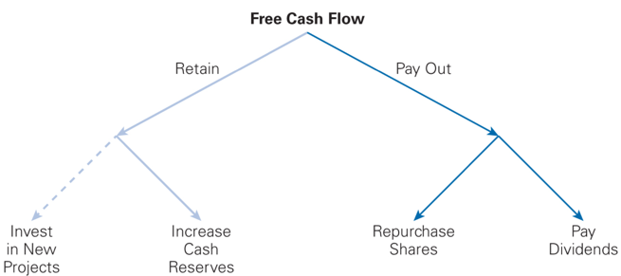**10. Payout Policy.** **(1) Uses of Free Cash Flow.** See figure, which is for an all-equity firm; a levered firm can also use FCF for interest and principal debt payments. *Payout Policy:* The ways in which firms return capital to their equity investors (Dividends, Share Repurchases). **(2) Dividends.** *Definition.* Payments made at the discretion of the corporation to its equity holders. The board of directors determines the amount of the firm’s dividend. *Types*. Ordinary dividend: usually paid at regular, quarterly intervals. Special Dividend: One-time dividend payment a firm makes, which is usually much larger than a regular dividend. Stock Dividend: When a company issues a dividend in shares of stock rather than cash to its shareholders. **(3) Share Repurchases.** *Definition.* An alternative way to pay cash to investors is through a share repurchase or buyback. The firm uses cash to buy shares of its own outstanding stock. These shares are generally held in the corporate treasury and can be resold if the company needs to raise money in the future. *Types.* Open Market Purchase. When a firm repurchases shares by buying shares in the open market just like any other investors. Can take a year or even more to do so. These represent about 95% of all repurchase transactions. Attention: The firm must not buy its shares in a way that might manipulate the price: Less than 25% of average daily trading volume. No transactions either at the market open or close (The purpose of this condition is to prevent the issuer

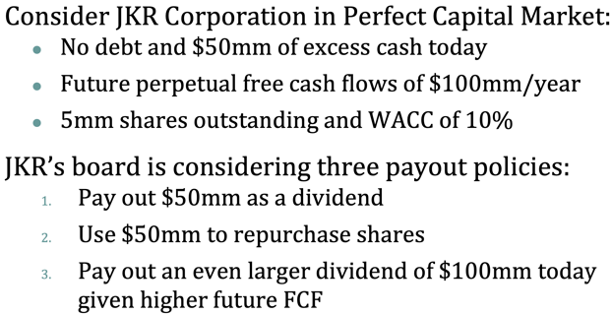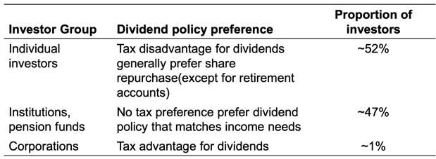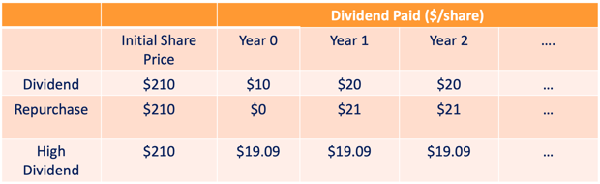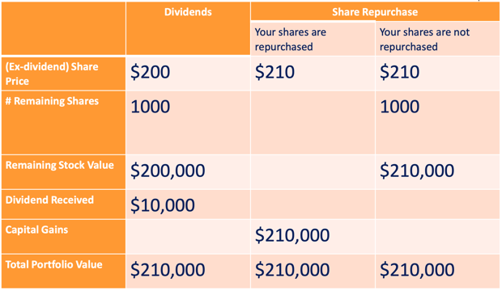from establishing either the opening or closing price of the stock, both of which are considered to guide the direction of trading). Tender Offer 要约收购. A public announcement of an offer to all existing security holders to buy back a specified amount of outstanding securities. Two ways: *At a pre-specified price:* typically set at a 10%-20% premium to the current market price. Over a pre-specified period of time: usually about 20 days. If shareholders do not tender enough shares, the firm may cancel the offer and not buyback occurs. *Dutch Auction:* A share repurchase method in which the firm lists different prices at which it is prepared to buy shares. Shareholders in turn indicate how many shares they are willing to sell at each price. The firm then pays the lowest price at which it can buy back its desired number of shares. Targeted Repurchase. When a firm purchases shares directly from a specific major shareholder. The purchase price is negotiated directly with the seller. It often occurs if a major shareholder desires to sell a large number of shares, but the market for the shares is not sufficiently liquid (Shareholder may be willing to sell at discount). **(4) Comparation.** *Modigliani-Miller Dividend Irrelevance.* In perfect capital markets, holding fixed the investment policy of a firm, the firm’s choice of dividend policy is irrelevant and does NOT affect the initial share price. Only a firm’s free cash flow determines the level of payouts that it can make to its investors. *Example.* 这个地方有三种Payout的方式. **1.** Pay Dividend: cum-dividend (i.e. with the dividend) price of JKR’s shares is 1050m/5m=210. ex-dividend price is (1050m-50m)/5m=200. In a perfect capital market, when a dividend is paid, the share price drops by the amount of the dividend. 2. Share Purchase: shares=5m-50m/210=4.762m. price=(1050m-50m)/4.762m=210. In perfect capital markets, an open market share repurchase has no effect on the stock price. Stock price is the same as the cum-dividend price if dividend was paid instead, future dividend per share increases. Preferences: In perfect capital markets, investors are indifferent between the firm distributing funds via dividends or share repurchases. By reinvesting dividends or selling shares, they can replicate either payout method on their own. 不想拿现金就再重新买股票, 想拿现金的就把股票卖掉. 3. High Dividend: raise the cash by selling new shares. Shares=5m+(100m-50m)/210=5.238m. price=(1050m+50m)/5.238m=210. Share price is unchanged. Current vs. Future Dividends**.** If JKR pays a higher current dividend, future dividends will be lower. If JKR pays a lower current dividend, future dividends will be higher. **(5) Real World.** In reality, capital markets are not perfect and these imperfections should determine a firm’s payout policy. Different payout policies have different tax implications. Smooth dividend payment conveys positive signal about the company’s profitability. *Tax Differences Across Investors.* The effective dividend tax rate differs across investors for a variety of reasons (Income level, Investment horizon, Tax jurisdiction, Type of investor or investment account). *Signaling with Payout Policy.* Firms change dividends infrequent-tly and dividends are much less volatile than earnings (Management believes that investors prefer stable dividends with sustained growth; Management desires to maintain a long-term target level of dividends as a fraction of long term expected earnings).

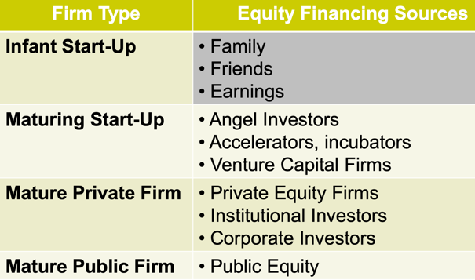**12. Raising Equity. (1) How do entrepreneurs raise equity capital?** Different stages have different way. **(2) Raising Equity in the Private Market.** *Pro-seed funding.* High risk: the company has not yet proven itself within the market. Repeat founders can secure funding without a working prototype and with just an idea. Three main sources of financing: Friends, family, and fool, Business Angels (BA), Accelerators (Government incubator, universities, and private companies, 各种孵化器). Financing early stage businesses. Given difficulty in assessing firm value at an early stage in the business, investors often rely on a convertible note rather than equity for financing. A convertible note is convertible into equity once the firm finances with equity for the first time. Note holders convert the value of their initial investment plus accrued interest into equity at a discount (often 20%) to the price paid by new investors. Investment sizes range from several hundred thousand dollars for individual investors to several million for angel groups. *Angel Investors.* For a new/start-up firm, angels are often a critical source of very early stage financing. *VC investors.* Definition. Invest in young, high-growth firms. Investments have a high probability of failure. Investments have the potential for very high rewards. Fund structure. Organized as a limited partnership (Typically are the LP’s, The GP’s run the VC firm). General partners have unlimited liabilities for all liabilities, and are in charge of daily operation. Limited partners are liable for business debt up to the contributed equity, partners do not participate in daily management. Role of VCs: deal sourcing, deal screening, deal making, monitoring, exit. Profit through successful exit: sell the stakes to another fund, acquisition or IPO. Primary exit strategies: US: ~80% of VC exits through M&A; China: IPO dominated (Other exit methods: later stage PEs, institutional investors). Features. Close-ended. Raises capital for investment through a one-time sale to LP. Fixed lifespan of 10 years. At the beginning of the fund, the LP do not hand over the money (“commitment”) immediately. VCs find the deal, negotiate the deal, and then request the LPs to send over the required amount: “capital call”. Illiquid investment, hard to value. Cost of VC funds. Annual management fee: 1.5-2.5% of committed capital. Carried interest: usually 20% (for some up to 30%) of positive returns (profits) go to the general partners. Benefits of investing in a VC fund. The VC makes many investments in start-ups leading to diversification; Access to the startup market; Expertise of general partners; VC funds can provide substantial capital. Costs of financing through a VC fund. VC funds demand a great deal of control (typically 1/3 of board seats and often represent largest voting block). The higher control can be viewed as an important benefit due to the nurturing / monitoring by VC firms to protect their investments. Corporate VC. Unlike financial VCs, a lot of Corporate VCs emphasize the strategic value of the startup. Big tech firms, biotechnology and telecommunication: Google, Intel, Qualcomm. *Convertible preferred stock.* When equity is sold for the first time to outside VC investors, convertible preferred stock is often used (senior claim on the firm’s assets, right to convert to common shares, usually no dividends). Why Convertible Preferred Stock? If business goes under, will have priority over common shareholders on the assets of the firm. If business does well, will convert and have all the rights and benefits of common shareholders. *Valuation of VC-backed firms.* Each time a firm raises money is referred to as a funding round. After the initial “seed round”, remaining capital raises are listed alphabetically. With each round of financing valuation is estimated as follows: Post-money Valuation = Pre-money Valuation + Amount Invested; Post-money Valuation = Amount Invested/ Percentage Ownership. *Institutional Investors.* Institutional investors, such as pension funds 养老基金, insurance companies, endowments 捐赠基金, and foundations, are active investors in private companies. May invest directly in private firms or invest indirectly by becoming limited partners in venture capital firms. *Later Stage PE Fund.* Similar to venture capital but less speculative. Fund later stage companies pre-IPO. Mature companies looking to grow their business by entering new markets or buying other companies. *Summary.* Equity investing in the private market: VC, Growth equity, Leveraged Buyout (Acquiring a public company using mostly debt). Private equity real estate, Fund of fund, Private equity in assorted assets (paintings, wines, etc). **(3) Raising Equity in the Public Market.** *Public Company.* A public company is a company whose shares can be traded on the public markets (mostly stock exchange: NYSE, NASDQ, SSE, SZSE). Unlisted public companies traded on OTC market. Direct transaction or through broker-dealers quoting stock prices. Size, listing cost, disclosure requirement, get delisted. *A Share.* RMB Common Stock. Domestically issued by Chinese corporations. Listed in Shanghai and Shenzhen exchanges. Traded with RMB by domestic institutions, organizations and individuals. Not physical stocks, they are kept electronically. Price fluctuation of A shares in Shanghai and Shenzhen exchanges is restricted with limit up and limit down (10%). *B Share.* RMB Special Stock. Issued by Chinese corporations and listed in Shanghai and Shenzhen. Recorded in RMB, but subscribed and traded in foreign currencies for foreign investors (including Hong Kong, Macao, Taiwan investors). In 2001, B shares are permitted to trade by domestic citizens. *A private company goes public through.* IPO: raising new public equities through IPO; SPAC: a publicly traded buyout company buys a private company; Direct listing (secondary offering): sell existing shares directly to the public on an exchange. *Being Public Advantages:* Greater Liquidity for Investors (E.g. VC exit, staying shareholder and founders have higher liquidity for their holding). Better access to capital. Public companies typically have access to larger amounts of capital through the public markets. Higher transparency. Information disclosure requirements reduces Information friction. Higher business awareness. *Being Public Disadvantages:* The equity holders become more widely dispersed: Makes it difficult to monitor management. Prices may be discounted to reflect the loss of control; The firm must satisfy all of the requirements of public companies: Information disclosure can force company to disclose business secret. Short-termism短视: company decisions affected by real-time stock price. **(4) Initial Public Offering (IPO).** The process of selling stock to the public for the first time. *The Process of IPO.* Step 1: Select the underwriter 承销商. An investment banking firm that manages a security issuance and designs its structure; Acts as an intermediary between the company seeking to go public (the issuer) and potential investors in the stock market; Syndicate: an IPO can involve a group of underwriters (China: issuance >= 30 million rmb has to be underwritten by syndicates); Lead underwriter. Step 2: SEC /证监会 filings: preliminary prospectus. Registration Statement: Provides financial and other information about a company to investors prior to a security issuance. Preliminary Prospectus: Preliminary information about the company; Doesn't include the final price of the IPO or the number of shares being offered; Circulated to investors before the stock is offered; Circulated to investors before the stock is offered. At the end of the IPO process: final Prospectus. Contains all of the details of the offering, including the number of shares offered and the offer price. Step 3: Valuation. Determining the value of the company. Two valuation approaches to arrive at a price range: (Compute the present value of the estimated future cash flows, Estimate the value by examining comparable companies). Step 4: Road Show. Convince potential buyers that the firm is a great investment and understand what the market thinks of the valuation. Step 5: Book-building role of the underwriter. The process of coming up with the offer price based on customers’ expressions of interest (one day before or same day of IPO). Step 6: Selling Shares. Best effort, Firm commitment, Dutch auction. Step 7: Post-IPO Market Making. Pricing the deal and managing risk. Once stock is traded publicly, lead underwriter usually makes a market in the stock and assigns an analyst to cover it → leads to greater liquidity. Preexisting shareholders are usually subject to a 180-day lockup: they cannot sell their shares for 180 days after the IPO. *IPO performances.* Generally, underwriters set the issue price such that the average first-day return is positive, 绝大多数IPO首日Return都为正. Why underprice? China: regulation over Price/Earning ratio. US: Supply side (The issuing firm may underprice to ensure a successful offering). Demand side **winner’s Curse** (Refers to a situation in which the winner of an auction, by virtue of being the highest bidder, is very likely to overpay the item he has won. You win when demand for the shares is low and the IPO is more likely to perform poorly). At the core of the Winner’s Curse is the adverse selection associated with the uncertainty of what is being bought. The required underpricing gets larger as the uncertainty increases. This is why underpricing is greatest for: Penny stocks underwritten through best efforts arrangements; IPOs in less developed stock markets. A firm can reduce uncertainty through: Greater disclosure / transparency in filings and road show. *Cost of IPO.* Fees from hiring professionals. (Underwriting fees: 3.5–7% of the offering proceeds, depends on size, $1 billion => 3.5%, Law firm fees: Can be around $1.7–2 million, Auditor fees: Can also be around $2 million). **(5) Direct listing.** No new shares will be listed and no capital will be raised; Spotify will float existing shares and let the market find the right price; No banks to serve as underwriters to set the pricing; Estimated costs. **(6) SPAC: special purpose acquisition company.** A private company going public by being acquired by a public shell company. Different from 借壳上市: the public shell is established specifically for SPAC, while 借壳上市 are from existing public firms. *Benefit of SPAC.* Acquired firm: no price uncertainty, less costly by avoiding roadshow, less stringent disclosure and regulation requirement, faster. Investors: option to redeem their shares if not approved of the deal. Sponsors: in exchange for a relatively small cash investment, sponsors receive a 20% stake in the SPAC. *Low success rate.* Limited disclosure add more uncertainty for investors. Hard to get investors’ consensus approval. Certain investors’ withdraw can trigger other investors’ withdraw. **(7) Seasoned Equity Offering 再融资.** *Definition.*When a public company offers new shares for sale. Public firms use SEOs to raise additional equity. Main difference from IPO: Market price already exists, so the price-setting process is much easier. Purpose: Fund new projects; Pay down debt. *Different types.* By what is issued: primary shares (new shares issued); secondary shares (shares sold by existing shareholders). By issued to whom: Cash Offer (A type of SEO in which a firm offers the new shares to public investors); Rights Offer (A type of SEO in which a firm offers the new shares only to existing shareholders); Private placement (to a limited number of qualified investors). *Why Market Reaction is Dropping?* Market timing: companies issue equity when shares are over-priced; Might suggest lack of liquidity; Increased supply lead to price drop; Dilution on existing shareholders. *Issuance Costs.* Underwriting fees amount to 5% of the proceeds of the issue (Rights offers have lower costs than cash offers). **(8) Public to Private: Leveraged Buyout (LBO).** A LBO is the acquisition of one company using a significant amount of borrowed money to meet the cost of acquisition. The acquirer buyout all shares of a public company and make it private. Purpose: raise leverage, gain control, change management/operation/increase profitability Profit by re-selling/re-IPO. *Other LBO models.* Split-up: Purchasing a company then selling off its different units for an overall dismantling of the acquired company. Portfolio: Acquire a couple of companies and merge them together, profit through synergies. Management buyout: Purchase of a company by its management and employees. *LBO: Issues.* High leverage, short-termism lead to the failure of the company. Profit-focused LBOs also can lead to negative social externalities.

必考点:

1. 中国公司在美国上市计算: 1)Rf选美国的; 2)Rm选美国的; 3)综合中美两国考虑税收

2. 实际中的beta怎么得到的？ 1)相关公司或行业的 lever beta; 2)根据他们的债权结构计算 un-lever beta; 3)进行加权平均. 4)根据公司自己的债权结构计算 lever beta.